
City Council Chamber
735 Eighth Street South
Naples, Florida 34102

City Council Regular Meeting – December 14, 2011 – 8:29 a.m.
Mayor Barnett called the meeting to order and presided.
ROLL CALL ITEM 1
Present: | Council Members:
Bill Barnett, Mayor | Douglas Finlay
John Sorey, III, Vice Mayor | Teresa Heitmann
 | Gary Price, II
 | Samuel Saad, III
 | Margaret Sulick
Also Present:
William Moss, City Manager | Tom Gillespie
Robert Pritt, City Attorney | Gloria Kovacs
Tara Norman, City Clerk | Lois Bolin
Roger Reinke, Assistant City Manager | Lise Sundria
Vicki Smith, Technical Writing Specialist | Fernando Zavala
Michael Leslie, Asst. Community Services Director | Antonio Faga
Paul Bollenback, Building Services Director | Arthur Neumann
Gregg Strakaluse, Streets & Stormwater Director | Vasil Babamov
Erica Goodwin, Planner | Willie Anthony
Adam Benigni, Planner | Homer Scoville
Robert Middleton, Utilities Director | Gordon Stojkoski
Robin Singer, Planning Director | William Kelly
Stephen Weeks, Technology Services Director | Media:
Bradford White, Solid Waste Superintendent | Kristine Gill, Naples Daily News
David Alger | Other interested citizens and visitors

INVOCATION AND PLEDGE OF ALLEGIANCE ITEM 2
Father Tom Gillespie, St. Ann Catholic Church.
ANNOUNCEMENTS ITEM 3
Mayor Barnett presented awards for the Christmas Parade floats. He was aided by Lois Bolin, Naples Backyard History, and Assistant Community Services Director, Michael Leslie.
SET AGENDA (add or remove items) ITEM 4
MOTION by Sorey to SET THE AGENDA adding Item 15 (Sam Noe Award resolution amendment); seconded by Sulick and unanimously carried, all members present and voting (Finlay-yes, Heitmann-yes, Price-yes, Saad-yes, Sorey-yes, Sulick-yes, Barnett-yes).

PUBLIC COMMENT ITEM 5
(8:26 a.m.) William Kelly, PO Box 2584, expressed concerns with regard to the granting of variances, stating that in his opinion, the Code of Ordinances is weakened with each petition approval. (It is noted for the record that a printed copy of Mr. Kelly’s statement is contained in the file for this meeting in the City Clerk’s Office.)
CONSENT AGENDA
APPROVAL OF MINUTES ITEM 6-a
November 2, 2011 Regular Meeting minutes; as submitted.
APPROVAL OF SPECIAL EVENT ITEM 6-b
2012 Collier County Heart Walk – American Heart Association – Cambier Park – 11/03/12.
RESOLUTION 11-13007 ITEM 6-c
A RESOLUTION APPROVING AN INTERLOCAL AGREEMENT BETWEEN THE CITY OF NAPLES AND COLLIER COUNTY FOR CONTRACTOR LICENSING BY COLLIER COUNTY; AUTHORIZING THE MAYOR TO EXECUTE THE INTERLOCAL AGREEMENT; AND PROVIDING AN EFFECTIVE DATE. Title not read.
MOTION by Finlay to APPROVE CONSENT AGENDA as submitted; seconded by Sulick and unanimously carried, all members present and voting (Finlay-yes, Heitmann-yes, Price-yes, Saad-yes, Sorey-yes, Sulick-yes, Barnett-yes).
END CONSENT AGENDA
RESOLUTION 11-13008 ITEM 7
A RESOLUTION OF THE CITY COUNCIL OF THE CITY OF NAPLES, FLORIDA, RELATING TO THE ESTABLISHMENT AND FUNDING OF THE PORT ROYAL CANAL DREDGING ASSESSMENT AREA; RATIFYING AND CONFIRMING THE INITIAL ASSESSMENT RESOLUTION; DETERMINING THAT CERTAIN REAL PROPERTY WILL BE SPECIALLY BENEFITED BY THE PORT ROYAL CANAL DREDGING ASSESSMENT AREA; ESTABLISHING THE METHOD OF ASSESSING THE COSTS OF THE IMPROVEMENTS AGAINST THE REAL PROPERTY THAT WILL BE SPECIALLY BENEFITED THEREBY; ESTABLISHING OTHER TERMS AND CONDITIONS OF THE ASSESSMENTS; APPROVING THE ASSESSMENT ROLL; PROVIDING THE METHOD OF COLLECTION; DIRECTING THE PROVISION OF NOTICE IN CONNECTION THEREWITH; AND PROVIDING AN EFFECTIVE DATE. Title read by City Attorney Robert Pritt (8:48 a.m.). City Manager William Moss explained that an amended resolution had been provided in a supplemental packet which included the insertion of the estimated cost of the dredging project, and its Appendix “B”, Affidavit of Publication, had been replaced with a “certified” copy.
Public Comment: (8:49 a.m.) None.
MOTION by Sorey to APPROVE RESOLUTION 11-13008 as submitted; seconded by Sulick and unanimously carried, all members present and voting (Finlay-yes, Heitmann-yes, Price-yes, Saad-yes, Sorey-yes, Sulick-yes, Barnett-yes).
RESOLUTION 11-13009 ITEM 8
A RESOLUTION DETERMINING OUTDOOR DINING PETITION 11-ODPB3 TO ALLOW A RESTAURANT (Alberto’s on Fifth) to provide outdoor dining in excess of 100 square feet ON PUBLIC PROPERTY THAT IS NOT DIRECTLY ABUTTING THE STOREFRONT OF THE RESTAURANT WHICH IT SERVES, SAID PROPERTY OWNED BY IBC Enterprise, LLC, located at 868 FIFTH Avenue South AND MORE FULLY DESCRIBED HEREIN; AND PROVIDING AN EFFECTIVE DATE. Title read by City Attorney Robert Pritt (8:50 a.m.). This being a quasi-judicial proceeding, Notary Public Vicki Smith administered an oath to those intending to offer testimony; all responded in the affirmative. City Council Members then made the following ex parte disclosures: Saad/visited the site and spoke with neighbors; Finlay, Barnett, Price, Sulick and Heitmann/visited the site but no contact; and Sorey/visited the site, spoke with the petitioner and petitioner’s agent, and noted additional documents received (depictions of seating plan, tables and chairs, from a prior petitioner’s submittal for the same location, copies of which are contained in the file for this meeting in the City Clerk's Office). Planner Erica Goodwin then provided a brief overview of the current petition as contained in her November 17 Council agenda memorandum as well as comparing it to the 2006 approval for similar outdoor dining by The Grape detailed in the background section of her November 17 staff report (see Attachments 1 and 2, respectively, for details). She pointed out that the prior request had included tables adjacent to the façade facing Fifth Avenue South as well as facing the alley to the east, which are not included in the subject request. Both staff and the Design Review Board (DRB) recommended approval of the request, she concluded.

Fernando Zabala, agent for the petitioner, noted that either the prior approved seating or that submitted would be agreeable. He then utilized an electronic presentation (a printed copy of which is contained in the file for this meeting in the City Clerk's Office) to briefly summarize the 8 tables and 32 seats requested for the outdoor dining area. Referencing the current design (Attachment 3), Vice Mayor Sorey explained that the petitioner had told him he was willing to remove the two outermost tables which would relieve a congested seating area. Mr. Sorey further suggested that four rectangular tables be added along the east façade. In response to Council Member Price, Mr. Sorey confirmed that the resulting umbrella setback would then be seven feet for the front seating area which currently reflects seven (see Attachment 3). Mr. Zabala agreed that the eight-foot setback would be reflected on the revised seating diagram should Council concur with Mr. Sorey’s recommendations. Mr. Price said that this would enhance pedestrian safety and aid in the enforcement of the approved design; Council Member Finlay agreed.

Council Member Sulick expressed concern that allowing tables in the alleyway adjacent to the City’s parking garage would also result in congestion. Mr. Zabala explained that those tables would abut the façade and no chairs would be placed on the side of the table nearest the walkway (east).

Planner Goodwin confirmed for Council Member Heitmann the petitioner’s request that the outdoor dining be available concurrent with the hours of operation. Mrs. Heitmann noted that this could then result in patrons in that location until 2:00 a.m. She therefore suggested use of the outdoor tables only until 12:00 a.m. due to the proximity to residential. Discussion followed regarding this issue during which City Attorney Pritt recommended that the petition be continued to allow for policy development.

Vice Mayor Sorey then proffered the motion reflected below, following which staff explained the need for two conditions contained in the resolution regarding a right-of-way permit, and Council Member Sulick received confirmation that no umbrellas were being proposed for use in the alleyway dining area.
Public Comment: (9:27 a.m.) None.

MOTION by Sorey to APPROVE RESOLUTION 11-13009 amended as follows: adding Section 3-3: “Petitioner shall submit to staff a revised site diagram consistent with six tables in front of establishment (30” square tables with 4 chairs each) and removal of two proposed tables on each side; four tables on east side of building; and an 8-foot umbrella setback line.” This motion was seconded by Finlay and unanimously carried, all members present and voting (Finlay-yes, Heitmann-yes, Price-yes, Saad-yes, Sorey-yes, Sulick-yes, Barnett-yes).
Council Member Heitmann requested that a workshop be scheduled for discussion of outdoor dining regulations; however, Council did not reach consensus to support this proposal.
RESOLUTION 11-13010 ITEM 9
A RESOLUTION DETERMINING OUTDOOR DINING PETITION 11-ODPB4 TO ALLOW A RESTAURANT (ROSSOPOMODORO) TO PROVIDE OUTDOOR DINING IN EXCESS OF 100 SQUARE FEET ON PUBLIC PROPERTY THAT IS NOT DIRECTLY ABUTTING THE STOREFRONT OF THE RESTAURANT WHICH IT SERVES, SAID PROPERTY OWNED BY WESTBURY NAPLES, INC., LOCATED AT 800 5TH AVENUE SOUTH AND MORE FULLY DESCRIBED HEREIN; AND PROVIDING AN EFFECTIVE DATE. Title read by City Attorney Robert Pritt (9:29 a.m.). This being a quasi-judicial proceeding, Notary Public Vicki Smith administered an oath to those intending to offer testimony; all responded in the affirmative. City Council Members then made the following ex parte disclosures: Saad/visited the site and spoke with neighbors and members of the Fifth Avenue South Business Improvement District (FASBID); Finlay and Price/visited the site; Barnett, Sulick and Heitmann/familiar with the site; and Sorey/visited the site and spoke with the petitioner and the petitioner’s agent; and all indicated e-mail contact with the petitioner’s agent. Planner Adam Benigni provided a brief overview of the item as contained in his November 28 memorandum (Attachment 4), including a review of the variance petition brought forward last year; the Code of Ordinances has been amended since that time, he explained, and therefore the current request for outdoor dining. Mr. Benigni also pointed out the objection to the petition by Assistant City Manager/CRA Director Roger Reinke due to the proposed removal of landscaping in the City right-of-way on the grounds that such action does not further the goals of the CRA and Fifth Avenue South Master Plans.

Should Council wish to approve the petition, Planner Benigni said, staff recommends imposition of the six conditions contained in the draft resolution, including receipt of a right-of-way permit by the petitioner. (A copy of the aforementioned document is contained in the file for this meeting in the City Clerk's Office.)

Attorney Antonio Faga, agent for the petitioner, submitted a diagram reflecting an amended outdoor dining area and landscaping plan (Attachment 5 / Exhibit 2). Mr. Benigni clarified that the aforementioned diagram differs from that in the submittal (Attachment 6 / Exhibit 1). The petitioner had attempted to submit the document for review by the Design Review Board (DRB) just prior to its meeting and the DRB had been instructed to either consider the item as submitted or continue it to allow for the diagram’s review. Because information considered by the DRB is brought forward for Council’s consideration, he continued, the original diagram had been presented. Mr. Faga indicated that the diagram he wished to submit had been in response to comments by staff and Council during its prior consideration as above noted. Council Member Price expressed concern that the DRB had not reviewed the more recent diagram and that comparison to that contained in the meeting packet was not feasible.

Discussion of the diagrams continued during which Landscape Architect Arthur Neumann (sworn separately) testified as to the differences between the two renditions of the outdoor dining area and its landscaping, noting that diagram #2 (see Attachment 5) contains more landscaping which will also be more dense and integrate to a greater extent into the existing landscaping. In response to Vice Mayor Sorey, Attorney Faga agreed that the petitioner would fund the relocation of the existing coconut palms to a location to be determined by the City.

Council Members Sulick and Saad each recommended deletion of one of the round tables resulting in a total of 22, rather than 24, seats (see Attachment 6). Mrs. Sulick also took issue with the removal of established landscaping in the right-of-way, and Council Member Finlay strongly agreed, noting the opposition by Mr. Reinke and the FASBID. Mr. Finlay also explained his overall concern that property owners are tending to construct their buildings to the property line and then later requesting use of the City rights-of-way for outdoor dining which necessitates removal of existing landscaping.

Attorney Faga then urged that Exhibit #2 (see Attachment 5) be considered to address Council Member Finlay’s concerns with loss of greenscape. Council Member Saad concurred for the same reason. As previously suggested by Council Member Heitmann in Item 8 above, Mr. Saad also recommended that a workshop discussion be scheduled to determine the future of outdoor dining along Fifth Avenue South. Council Member Price also indicated that he continued to have concerns with possible impediment of pedestrian traffic at the southeast corner of Eighth Street and Fifth Avenue South, and Mr. Saad noted that he believed the new design (Exhibit #2) addressed that issue. Mr. Saad then proffered a motion for approval which Council Member Heitmann seconded, recommending that one of the two person tables be removed from the outdoor dining area leaving a total of 22 seats. Vice Mayor Sorey added that he believed the table adjacent to the building at the west end should also be eliminated, resulting in a total of 20 seats; he also asked that the petitioner’s agreement to fund relocation of the two coconut palms as referenced above be included; Council Members Saad and Heitmann agreed.

Additional review of the resolution followed, the final motion being reflected below.
Public Comment: (10:23 a.m.) None.
MOTION by Saad to APPROVE RESOLUTION 11-13010 amended as follows: Deleting Sections 3-2, 3-3, 3-4, and 3-5; renumbering Section 3-6 accordingly to 3-2; adding new Section 3-3 requiring submittal of revised site design #2 reflecting the removal of one 2-top table abutting building at west end; removal of one 4-top table from outdoor dining area and replacing with a 2-top for total of 20 chairs; and new Section 3-4 requiring petitioner to fund relocation of two coconut palms to City-directed location (see Attachment 5 for site design #2). This motion was seconded by Heitmann and carried 6-1, all members present and voting (Finlay-no, Sulick-yes, Heitmann-yes, Price-yes, Sorey-yes, Saad-yes, Barnett-yes).
Recess: 10:26 a.m. to 10:44 a.m. It is noted for the record that the same Council Members were present when the meeting reconvened.
RESOLUTION 11-13011 ITEM 10
A RESOLUTION DETERMINING INDOOR AND OUTDOOR LIVE ENTERTAINMENT PETITION 11-LE2 FOR AQUA RESTAURANT LOCATED AT 862 FIFTH AVENUE SOUTH, MORE FULLY DESCRIBED HEREIN; AND PROVIDING AN EFFECTIVE DATE. Title read by Planning Director Robin Singer (10:44 a.m.). This being a quasi-judicial proceeding, Notary Public Vicki Smith administered an oath to those intending to offer testimony; all responded in the affirmative. City Council Members then made the following ex parte disclosures: Saad, Price and Barnett/familiar with the site but no contact; Finlay, Sulick and Heitmann/visited the site but no contact; and Sorey/visited the site and attended the opening of the establishment. Planning Director Robin Singer provided a brief overview as contained in her November 28 memorandum (Attachment 7), noting that while the petitioner has indicated that entertainment would not routinely be scheduled when the business opens (11:00 a.m.), the intent was to be able to provide that amenity for special events when needed, which is similar to The Inn on Fifth’s permit, she added. In response to Vice Mayor Sorey, she confirmed that the request had not specified the number of entertainers permitted to perform.

Petitioner Gordon Stojkoski concurred with Ms. Singer’s synopsis above, clarifying that live entertainment would begin at 9:00 p.m. unless a special event had been scheduled such as a private party; there would however be no more than three or four performers at a time. Council Members Price and Sulick agreed that entertainment should not begin prior to 4:00 p.m., and following a brief discussion regarding disc jockeys, the motion below was proffered.
Public Comment: (10:59 a.m.) None.
MOTION by Sorey to APPROVE RESOLUTION 11-13011 amended as follows: Section 2-1: “…entertainment with a maximum of four entertainers from 4:00 p.m. 11:00 a.m. …”; and reflecting commencement of entertainment at 4:00 p.m. throughout remainder of Section 2-1. This motion was seconded by Heitmann and carried 6-1, all members present and voting (Saad-yes, Heitmann-yes, Price-yes, Sorey-yes, Sulick-yes, Finlay-no, Barnett-yes). (It is noted for the record that Section 2 was inadvertently numbered Section 3 in the submitted resolution.)
RESOLUTION 11-13012 ITEM 11
A RESOLUTION DETERMINING PETITION 11-SD5 FOR THE 215 AND 225 FIFTH STREET SOUTH PRELIMINARY AND FINAL (RECORD) PLAT APPROVAL TO REPLAT A PARCEL (APPROXIMATELY 7,500 SQUARE FEET) WITH AN EXISTING DUPLEX INTO TWO PLATTED LOTS OF APPROXIMATELY 3,750 SQUARE FEET EACH, OWNED BY HOMER G. SCOVILLE AND WILLIAM AND SANDRA HOBBY AND LOCATED AT 215-225 FIFTH STREET SOUTH, MORE FULLY DESCRIBED HEREIN; AND PROVIDING AN EFFECTIVE DATE. Title read by City Attorney Robert Pritt (11:04 a.m.). This being a quasi-judicial proceeding, Notary Public Vicki Smith administered an oath to those intending to offer testimony; all responded in the affirmative. City Council Members then made the following ex parte disclosures: Saad/visited the site and spoke with the petitioner and City staff; Finlay and Sulick/visited the site but no contact; Price/familiar with the site and spoke with the petitioner; Barnett and Heitmann/familiar with the site but no contact; and Sorey/visited the site and spoke with the petitioner. Planner Adam Benigni briefly reviewed the request as contained in his November 20 memorandum (Attachment 8), noting that staff and the Planning Advisory Board (PAB) recommended approval.

Petitioner Homer Scoville then reviewed the reasoning behind the request, stating that each of the two units located on the site is completely separate, sharing only a common dividing wall. He confirmed that the two owners had submitted an Owners Use, Maintenance and Operating Agreement which had been approved by staff and that reference to the agreement would be noted on the record plat; the agreement had been a condition of approval for the April 20, 2011 variance applicable to the property (see Attachment 8). Fee simple ownership of each one-half of the property is the intent of the request, Mr. Scoville concluded.

In response to City Attorney Pritt, Planner Benigni confirmed that reference to the aforementioned use agreement is reflected on the plat.
Public Comment: (11:12 a.m.) None.
MOTION by Price to APPROVE RESOLUTION 11-13012 as submitted; seconded by Sorey and carried 6-1, all members present and voting (Finlay-yes, Heitmann-yes, Price-yes, Saad-yes, Sorey-yes, Sulick-no, Barnett-yes).
Council Member Sulick indicated that her opposition to the above item was due to her belief that the practice of granting such variances should not occur until the relevant issues are discussed and a policy with criteria determined.
RESOLUTION 11-13013 ITEM 12
A RESOLUTION DECLARING SUPPORT FOR POLICE OFFICER AND FIREFIGHTER PENSION PLAN AND DISABILITY PRESUMPTION REFORMS TO MAKE THE PLANS SUSTAINABLE, SOUND AND SECURE FOR CURRENT AND FUTURE POLICE OFFICERS AND FIREFIGHTERS IN FLORIDA; SUPPORTING LOCAL COLLECTIVE BARGAINING WITHOUT STATE MANDATES; SUPPORTING REMOVAL OF THE EXTRA BENEFIT REQUIREMENT TO RECEIVE PREMIUM TAX FUNDS; ALLOWING CITIES WHO HAVE OPTED OUT OF CHAPTER 175 AND CHAPTER 185 PENSION PLANS TO USE PREMIUM TAX FUNDS PAID BY CITY RESIDENTS FOR CITY POLICE AND FIRE PENSIONS; PROHIBITING THE STATE DIVISION OF RETIREMENT FROM IMPOSING ONEROUS ADMINISTRATIVE POLICIES THAT INCREASE THE COST OF PENSIONS; URGING THE FLORIDA LEGISLATURE TO ADOPT AND THE GOVERNOR TO APPROVE PENSION REFORM LEGISLATION DURING THE 2012 LEGISLATIVE SESSION; DIRECTING THE CITY CLERK TO TRANSMIT A COPY OF THIS RESOLUTION TO THE GOVERNOR, AND THE FLORIDA LEGISLATURE; AND PROVIDING AN EFFECTIVE DATE. Title read by City Attorney Robert Pritt (11:14 a.m.) In response to Council Member Finlay, Assistant City Manager Roger Reinke pointed out that the resolution contains a Section 4 requesting that pension reform legislation include a provision either allowing cities to use premium tax money paid by their residents to fund City police and fire pension plans, or that those same residents not be required to pay the premium tax.
Public Comment: (11:25 a.m.) None.
MOTION by Price to APPROVE RESOLUTION 11-13013 as submitted; seconded by Saad and unanimously carried, all members present and voting (Finlay-yes, Heitmann-yes, Price-yes, Saad-yes, Sorey-yes, Sulick-yes, Barnett-yes).
CLERK’S TRACKING #11-00046 ITEM 13
AWARDING A CONTRACT FOR THE PURCHASE OF FLYGT PUMPS FOR VARIOUS LOCATIONS THROUGHOUT THE CITY FOR THE UTILITIES DEPARTMENT: \ VENDOR: XYLEM INC., FORT MYERS, FLORIDA \ COST: $250,000 \ FUNDING: CIP 12X04 – SUBMERSIBLE PUMPS ($100,000 – WATER / SEWER FUND) AND CIP 12M07 – WASTEWATER TREATMENT PLANT PUMPS ($150,000 – WASTEWATER FUND). (11:26 a.m.) City Manager William Moss provided a brief overview of the request as contained in the November 30 memorandum by Utilities Director Robert Middleton (Attachment 9).
Public Comment: (11:26 a.m.) None.
MOTION by Barnett to APPROVE THIS ITEM as submitted; seconded by Sulick and unanimously carried, all members present and voting (Finlay-yes, Heitmann-yes, Price-yes, Saad-yes, Sorey-yes, Sulick-yes, Barnett-yes).

RESOLUTION 11-13014 (Added Item – see Item 4 above) ITEM 15
A RESOLUTION AMENDING THE GUIDELINES FOR THE SAM NOE AWARD AS SET FORTH IN THE ATTACHED EXHIBIT “A”; REPEALING RESOLUTION 06-11371; AND PROVIDING AN EFFECTIVE DATE. Title read by City Attorney Robert Pritt (11:27 a.m.). Deputy City Clerk Jessica Rosenberg noted that the amendments were in response to Council direction received during that week’s workshop with regard to the Sam Noe Award, namely, inclusion of members of the Naples Airport Authority as possible nominees as well as current or past members of all appointed city of Naples boards or committees.
Public Comment: (11:28 a.m.) None.
MOTION by Finlay to APPROVE RESOLUTION 11-13014 as submitted; seconded by Price and unanimously carried, all members present and voting (Finlay-yes, Heitmann-yes, Price-yes, Saad-yes, Sorey-yes, Sulick-yes, Barnett-yes).
PUBLIC COMMENT
(11:28 a.m.) None.
CORRESPONDENCE AND COMMUNICATIONS
(11:28 a.m.) Council Member Finlay referenced his submittal of information regarding Collier County’s ordinance requiring board and committee members to resign in order to run for office. (A copy of the aforementioned ordinance is contained in the file for this meeting in the City Clerk's Office.) Following a brief discussion, consensus was reached that the review of the remaining zero-based budgeting presentations would continue, with those meetings in which it is discussed adjourning at 4:00 p.m., as well as no hiatus of the discussions is to occur during the upcoming elections. Council Members then extended holiday wishes to all.
ZERO-BASED BUDGETING (Continued from 12/12/11 workshop) ITEM 14
PRESENTATION OF ZERO-BASED BUDGETS, SUMMARIZING CURRENT AND PAST BUDGETED EXPENDITURES, CHANGES IN PERSONNEL, THE ESTIMATED COST OF FUNCTIONS, ACTIVITIES, AND SERVICES, HOW BUDGETS MAY BE REDUCED BY 10%, WHAT SERVICES WOULD BE OFFERED IF 10% ADDITIONAL FUNDING WERE AVAILABLE, AND WHAT ARE THE FUTURE REQUIREMENTS FOR NEW FACILITIES. (It is noted for the record that this item was continued from the December 12, 2011 workshop.)

Building Services Department
Building Services Director Paul Bollenback utilized an electronic presentation during review of the department’s budget (a printed copy of which is contained in the file for this meeting in the City Clerk's Office and excerpted text of which is appended hereto as Attachment 10). He assured Vice Mayor Sorey that his employees’ performance can be tracked although he cautioned that plans submitted vary greatly in complexity and therefore review time. Mr. Sorey explained that he believed performance should nevertheless be included in the quarterly reports submitted to Council; this would also allow tracking of the increased level of service anticipated from the proposed increase in staff. He further urged that plans be submitted electronically with pertinent GPS (Global Positioning System) information reflected thereon when available. Mr. Bollenback then confirmed that the Floodplain Coordinator position is full-time and that the City funding such a position actually benefits residents by lowered insurance rates.

Council Member Finlay commended Mr. Bollenback for rapidly responding to the onset of the economic crisis, noting that the department is totally self-funded with no use of ad valorem tax monies. He agreed with Vice Mayor Sorey that the use of the excess fund reserves for additional staffing should be supported, although he questioned one employee’s significant overtime. Mr. Bollenback indicated the possibility that adjusting the scheduled work hours to coincide with the time of demand would address this issue.

Council Member Heitmann questioned the length of time necessary for completion of the plans review process. City Manager William Moss explained that it should be noted that the process can be halted if one inspection or review reveals an issue that must be addressed by the applicant. Mr. Bollenback then clarified for Mrs. Heitmann that the proposed transfer of the site plans engineer to the Streets & Stormwater Department is to merely physically locate that employee among others performing similar work thereby facilitating interaction of staff.

Council Member Saad commended the performance and efficiency of the Building Department, characterizing it as the best in southwest Florida. Mr. Bollenback then confirmed for Mr. Saad that permit tracking is available online. He also assured him that most inspections can be provided on the day requested; should delays become an issue then an additional inspector may be necessary. He cautioned against a moratorium on fees, although he agreed that they could be reviewed, pointing out that the current reserves had been amassed during a period of high construction activity in the late 1990’s and early 2000’s. This will not occur again as the City is virtually built-out. In response to Mr. Saad, Mr. Bollenback indicated that he would research discrepancies between the adopted budget and the reserve fund and respond via e-mail to Council. Mr. Saad then recommended that the City Attorney review statutes governing the use of building fund reserves and whether pertinent Planning Department functions could be transferred to the Building Department which would lessen the use of the General Fund; he also supported electronically submitted plans.

A brief discussion ensued with regard to all employees tracking their time for individual functions and it was decided that this should be considered at a later date.
Recess: 12:44 p.m. to 1:19 p.m. It is noted for the record that the same Council Members were present when the meeting reconvened and Item 14 continued with discussion of the Building Department presentation resuming.
Council Member Price suggested that document scanning be consolidated in the Building Department, and City Manager Moss explained that its equipment is utilized eight hours per day although the suggestion could be researched. Commending Mr. Bollenback on his performance, Mr. Price also supported the aforementioned tracking of level of service with regard to plan review, and suggested that the current data be used as a baseline for determining improvement with proposed staff additions.

Council Member Sulick expressed her support of a determination of whether various Planning functions might be funded by the Building Department. Furthermore, she said that while she could support electronically submitted documents when feasible, most development in the City is single family residential and therefore may be prohibitive for homeowners who frequently amend their building plans; this would result in a longer approval time. Mr. Moss agreed, pointing out that it would be more efficient to have final plans in electronic form rather than multiple renditions throughout a project.

Staff received confirmation from Council to proceed with the preliminary recruiting process for the positions proposed during the presentation (see Attachment 10, Page 4) and Council directed that the above referenced review of permitting fees be considered in the future.

Solid Waste Division
Also utilizing an electronic presentation, Utilities Director Robert Middleton reviewed the Solid Waste Division zero-based budget exercise, concluding with an overview of the proposed recycle transfer facility site to be located on the Naples Municipal Airport Property; design and permitting should be completed by July 2012, he added. (It is noted for the record that a printed copy of this presentation is contained in the file for this meeting in the City Clerk's Office / excerpted text of which is appended hereto as Attachment 11.)

Mr. Middleton agreed with Council Member Finlay’s observation that under residential garage collections – multi-family collection, the reference to 10,000 multi-family units does not include service to condominiums other than the collection of large items; condominiums, which utilize commercial refuse containers (referred to as dumpsters), are included under commercial garbage collections (see Attachment 11, Page 3).

Vice Mayor Sorey received confirmation that the automated recycling trucks have in fact been purchased although not delivered. In addition, Mr. Middleton noted that staff had been researching alternative fueled vehicles for the current residential back door pickup service provided by the City and two or three makes of battery-powered ones had been found to replace the currently utilized Ford Rangers; the provision of compressed natural gas fueling stations for vehicles is several years away, he added. Director Middleton then clarified that the person driving the vehicle to the Lee County recycle station has other duties when not performing that function, such as relief for vacations and sick leave to maintain the current level of service.

Council Member Price questioned the potential savings should the City’s solid waste be picked up once a week versus the current twice per week. Mr. Middleton stated that the amount of refuse would remain constant, involve more trips to the landfill, and could in fact require the hiring of additional staff. Mr. Price indicated that he had research and recommendations regarding this that he would provide at a later time. Vice Mayor Sorey then noted that he had been informed by numerous residents that they were more than willing to pay the cost for twice a week service; City Manager Moss agreed with this observation.

In response to Council Member Saad, Director Middleton pointed out that with the use of the City’s GPS system, the number of routes as well as staff had already been reduced thereby increasing efficiencies. Mr. Saad then suggested that a user fee be considered for bulk and agriculture pick-up service and Council Member Finlay stated that a time study had been completed in 2006 regarding the provision of the recycle material back-door service versus curb side pick-up.

Mr. Middleton explained for Council Member Sulick that the daily commercial collection service is as requested and the customer pays for that service. He also clarified for Council Member Heitmann that the presentation contains only possible alternative processes under outsourcing and consolidation (see Attachment 11, Page 4), not recommendations. Vice Mayor Sorey then suggested that a rate study be undertaken with regard to solid waste services.

Solid Waste Superintendent Bradford White explained for Council that while no ordinance exists, staff recommends no longer than 72 hours as the maximum time for horticultural waste to remain in the right-of-way for pickup. Vice Mayor Sorey stated that the numerous lawn service companies place their debris in the horticultural waste piles rather than hauling it away as required.

Council Member Price then commended the level of service provided by this division’s staff and Vice Mayor Sorey noted that staff routinely interacts with residents well beyond the scope of their job description. All Utilities employees are required to attend “Eyes on the Street” classes sponsored by the City’s Police Department, Mr. Middleton said, which educates them for activities to be alert to.
Recess: 2:28 p.m. to 2:42 p.m. It is noted for the record that the same Council Members were present when the meeting reconvened and discussion of Item 14 continued.
Technology Services
Prior to beginning his dissertation, Technology Services Director Stephen Weeks pointed out for Council Member Price that the City had originally planned a centralized scanning program with the Building Department’s equipment (see Page 9 above for additional discussion); due to lack of staff this did not come to fruition. Such a system could possibly be sought via the enterprise system currently being researched, he added. Mr. Weeks then utilized an electronic presentation of the department’s budget (a printed copy of which is contained in the file for this meeting in the City Clerk's Office / excerpted text of which is appended hereto as Attachment 12), following which he advised Council Member Saad that cloud computing and virtual servers are being investigated, especially with regard to federal standards, security and cost/benefit; cloud-based backup in real time is also being researched, he added. A ten-year business plan is to be presented within the near future, Mr. Weeks maintained. A brief discussion of placing documents on-line followed during which he advised that some would need redaction prior to posting and that it should be determined what documents would actually be accessed; many recent ones are currently routinely posted, he added. City Manager Moss then assured Mr. Saad that GPS equipment is being installed in police cars and it is yet to be determined the cost effectiveness of being able to electronically monitor the location of emergency response vehicles at all times; lack of adequate staffing to monitor this function is a key factor, he said. Mr. Weeks added that the accuracy of some GPS units remains an issue and that the City is working towards a centralized system for all pertinent departments.

Council Member Finlay then noted an error in the presentation regarding the cost of the help desk personal services (see Attachment 12, Page 3). Mr. Finlay also expressed support for the use of technology in saving money while increasing the level of service provided. Mr. Weeks noted that staff had been in contact with the GFOA (Government Finance Officers Association) for input as to what systems other similar municipalities are utilizing.

Mr. Weeks then assured Vice Mayor Sorey that the Technology Services Department does coordinate with other department, with regard to utilizing Smart Cities concepts when purchasing systems, and Mr. Sorey questioned when staff would be returning with an integrated software and hardware proposal City-wide. Mr. Moss indicated that staff had the understanding that a long term plan was desired and recommendations could be expected in a month or so; the plan would be completed within six months, he added. Mr. Weeks clarified for Mr. Sorey that a City-wide Wi-Fi system would be costly and access to broadband is available throughout the area; the technology in this area is constantly changing.

Council Member Heitmann commended staff for its research efforts in the area of technology, cautioning that it is a rapidly changing industry and timing is critical when purchasing new systems and ascertaining its necessity and applicability to the City’s daily operations.

In conclusion, Mr. Weeks stated that the best servers available are a must when allocating funding.

ADJOURN
3:41 p.m.

______________________________
Bill Barnett, Mayor

______________________________
Tara A. Norman, City Clerk

Minutes prepared by:

____________________________________
Vicki L. Smith, Technical Writing Specialist

Minutes Approved: 02/15/12

Attachment 1 / Page 1 of 2
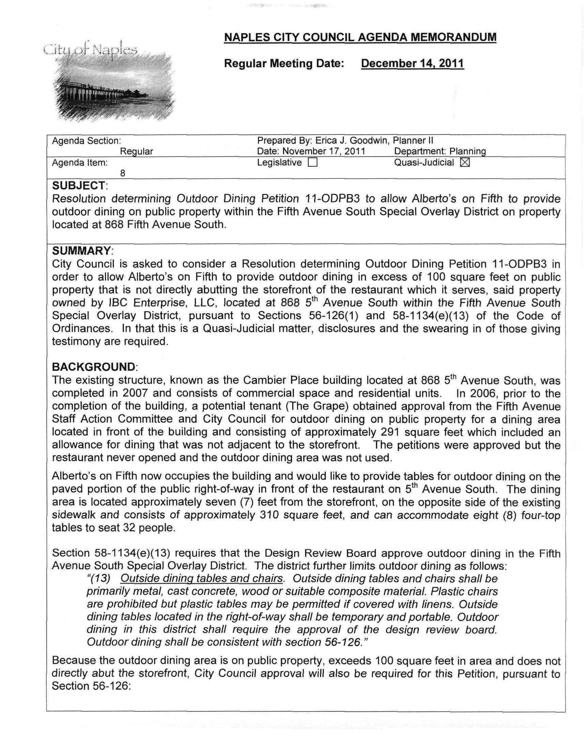
Attachment 1 / Page 2 of 2
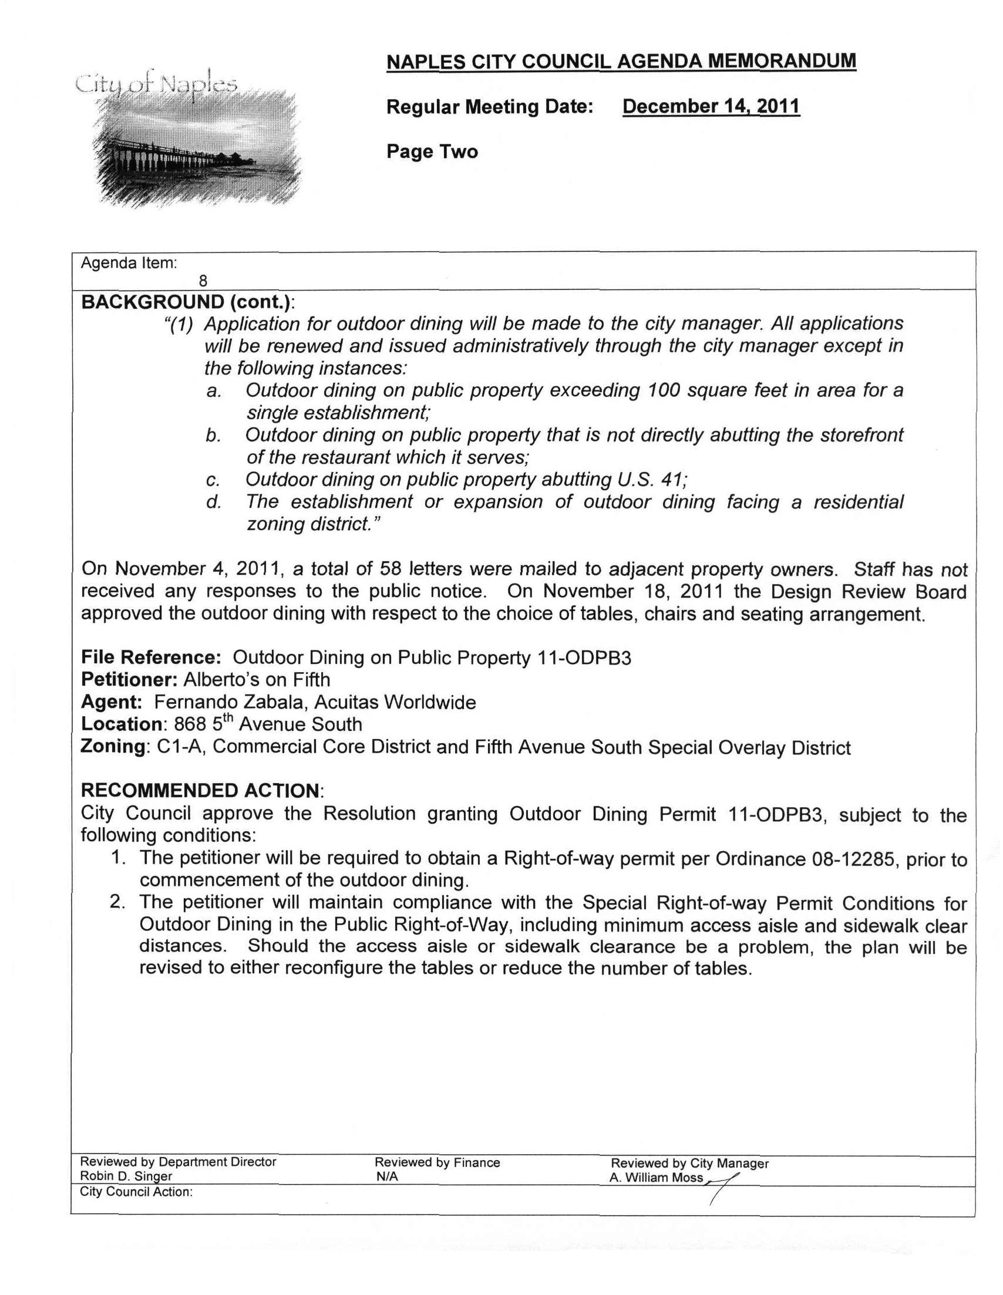
Attachment 2 / Page 1 of 2
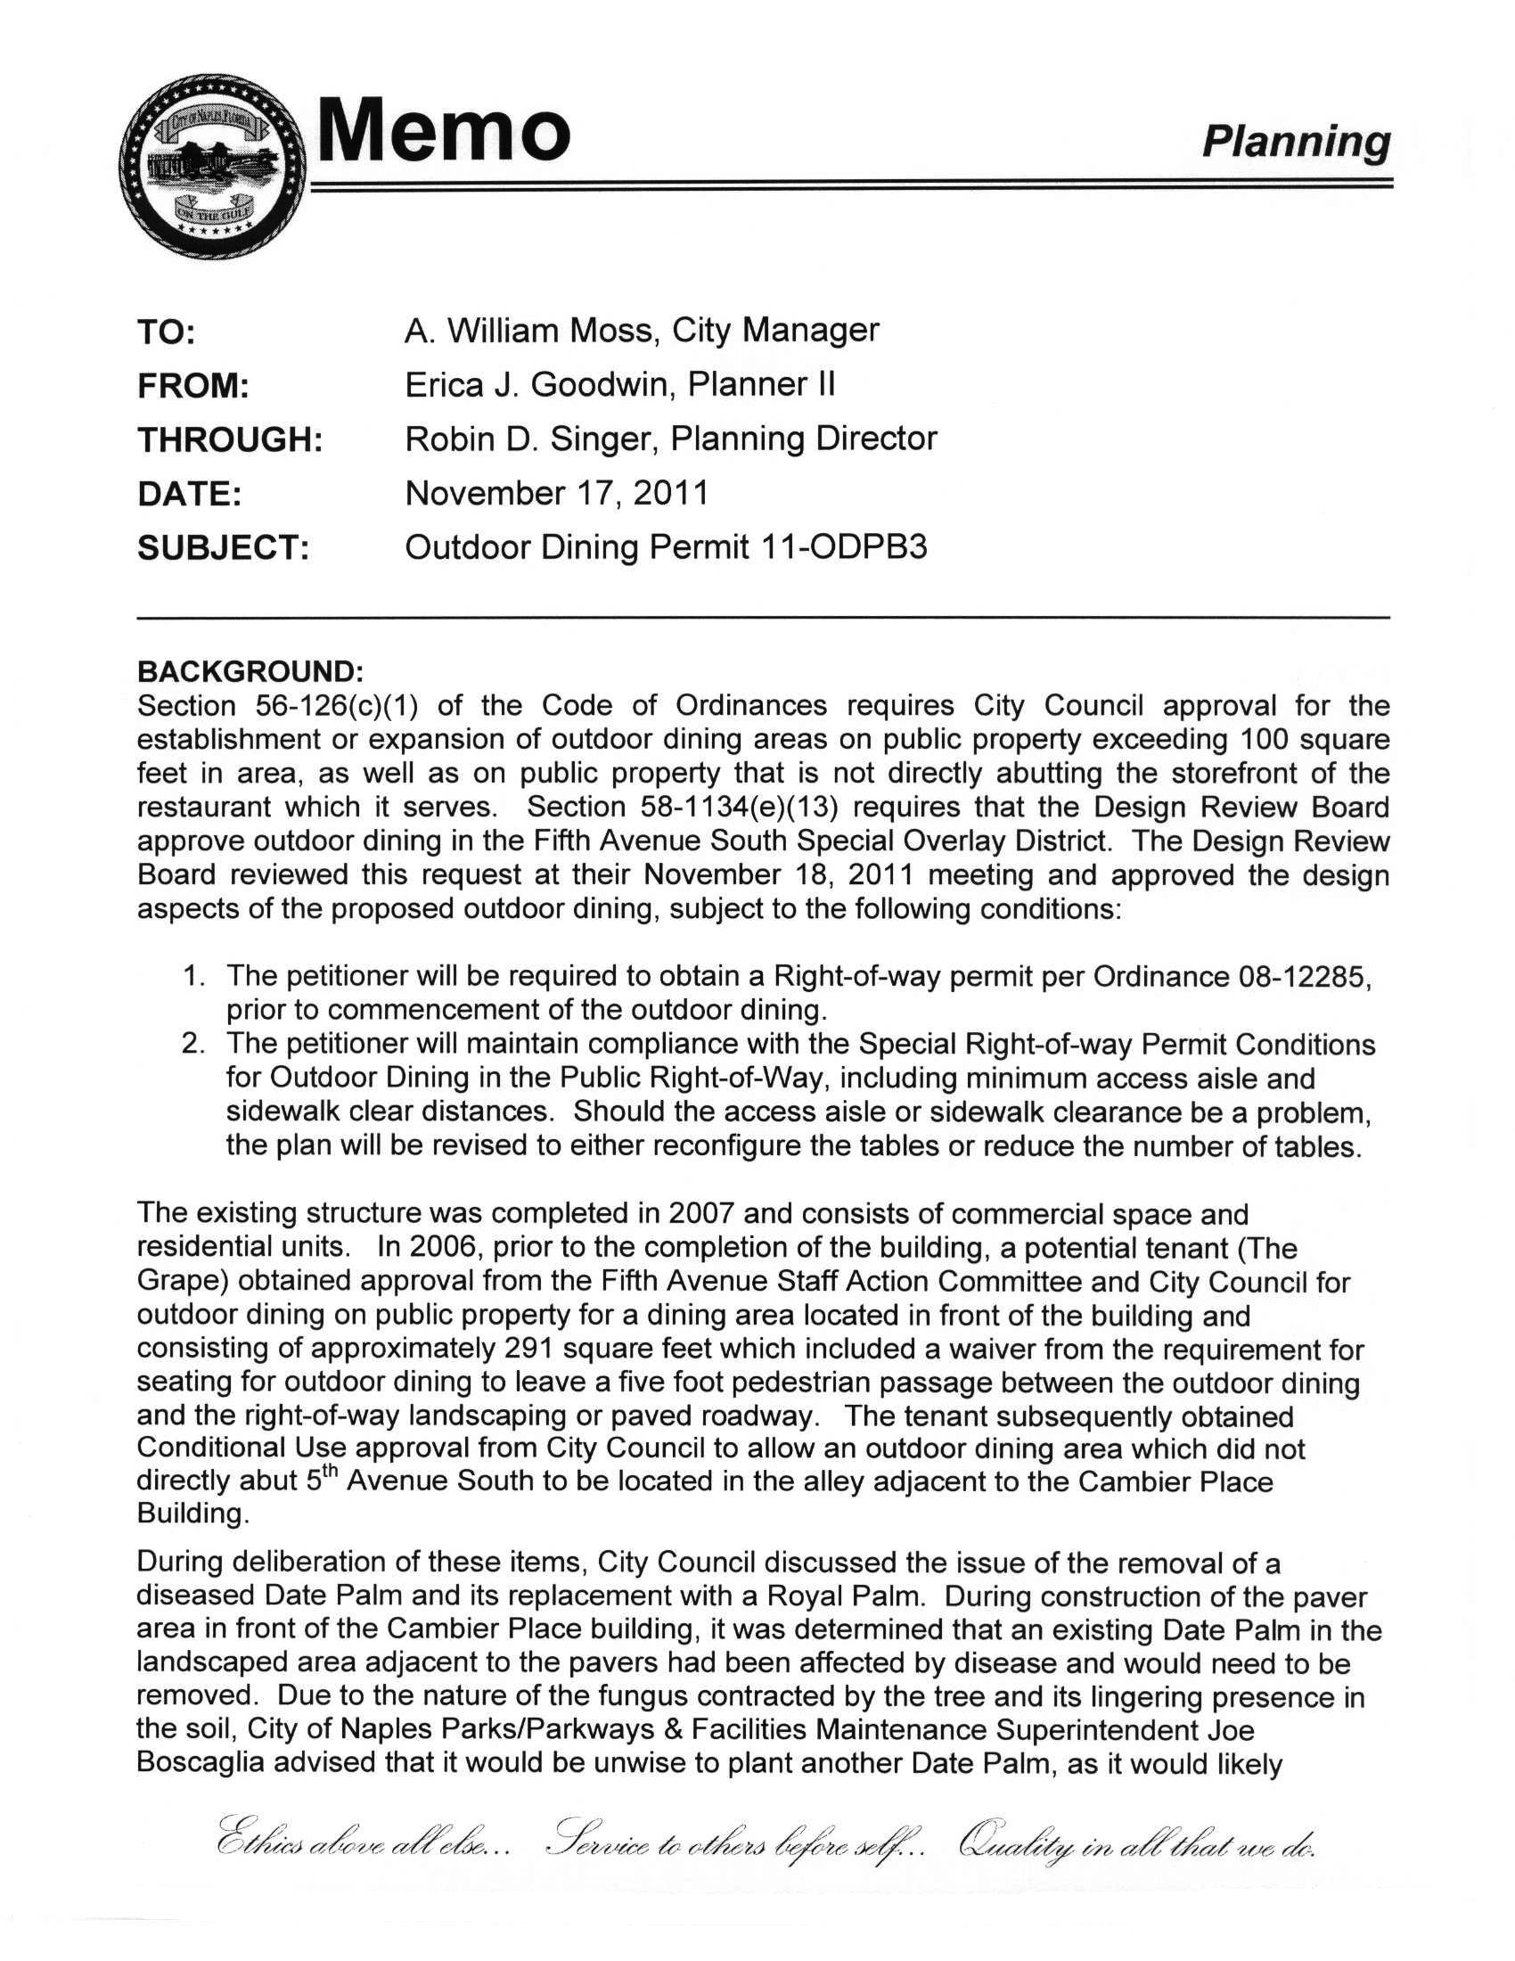
Attachment 2 / Page 2 of 2
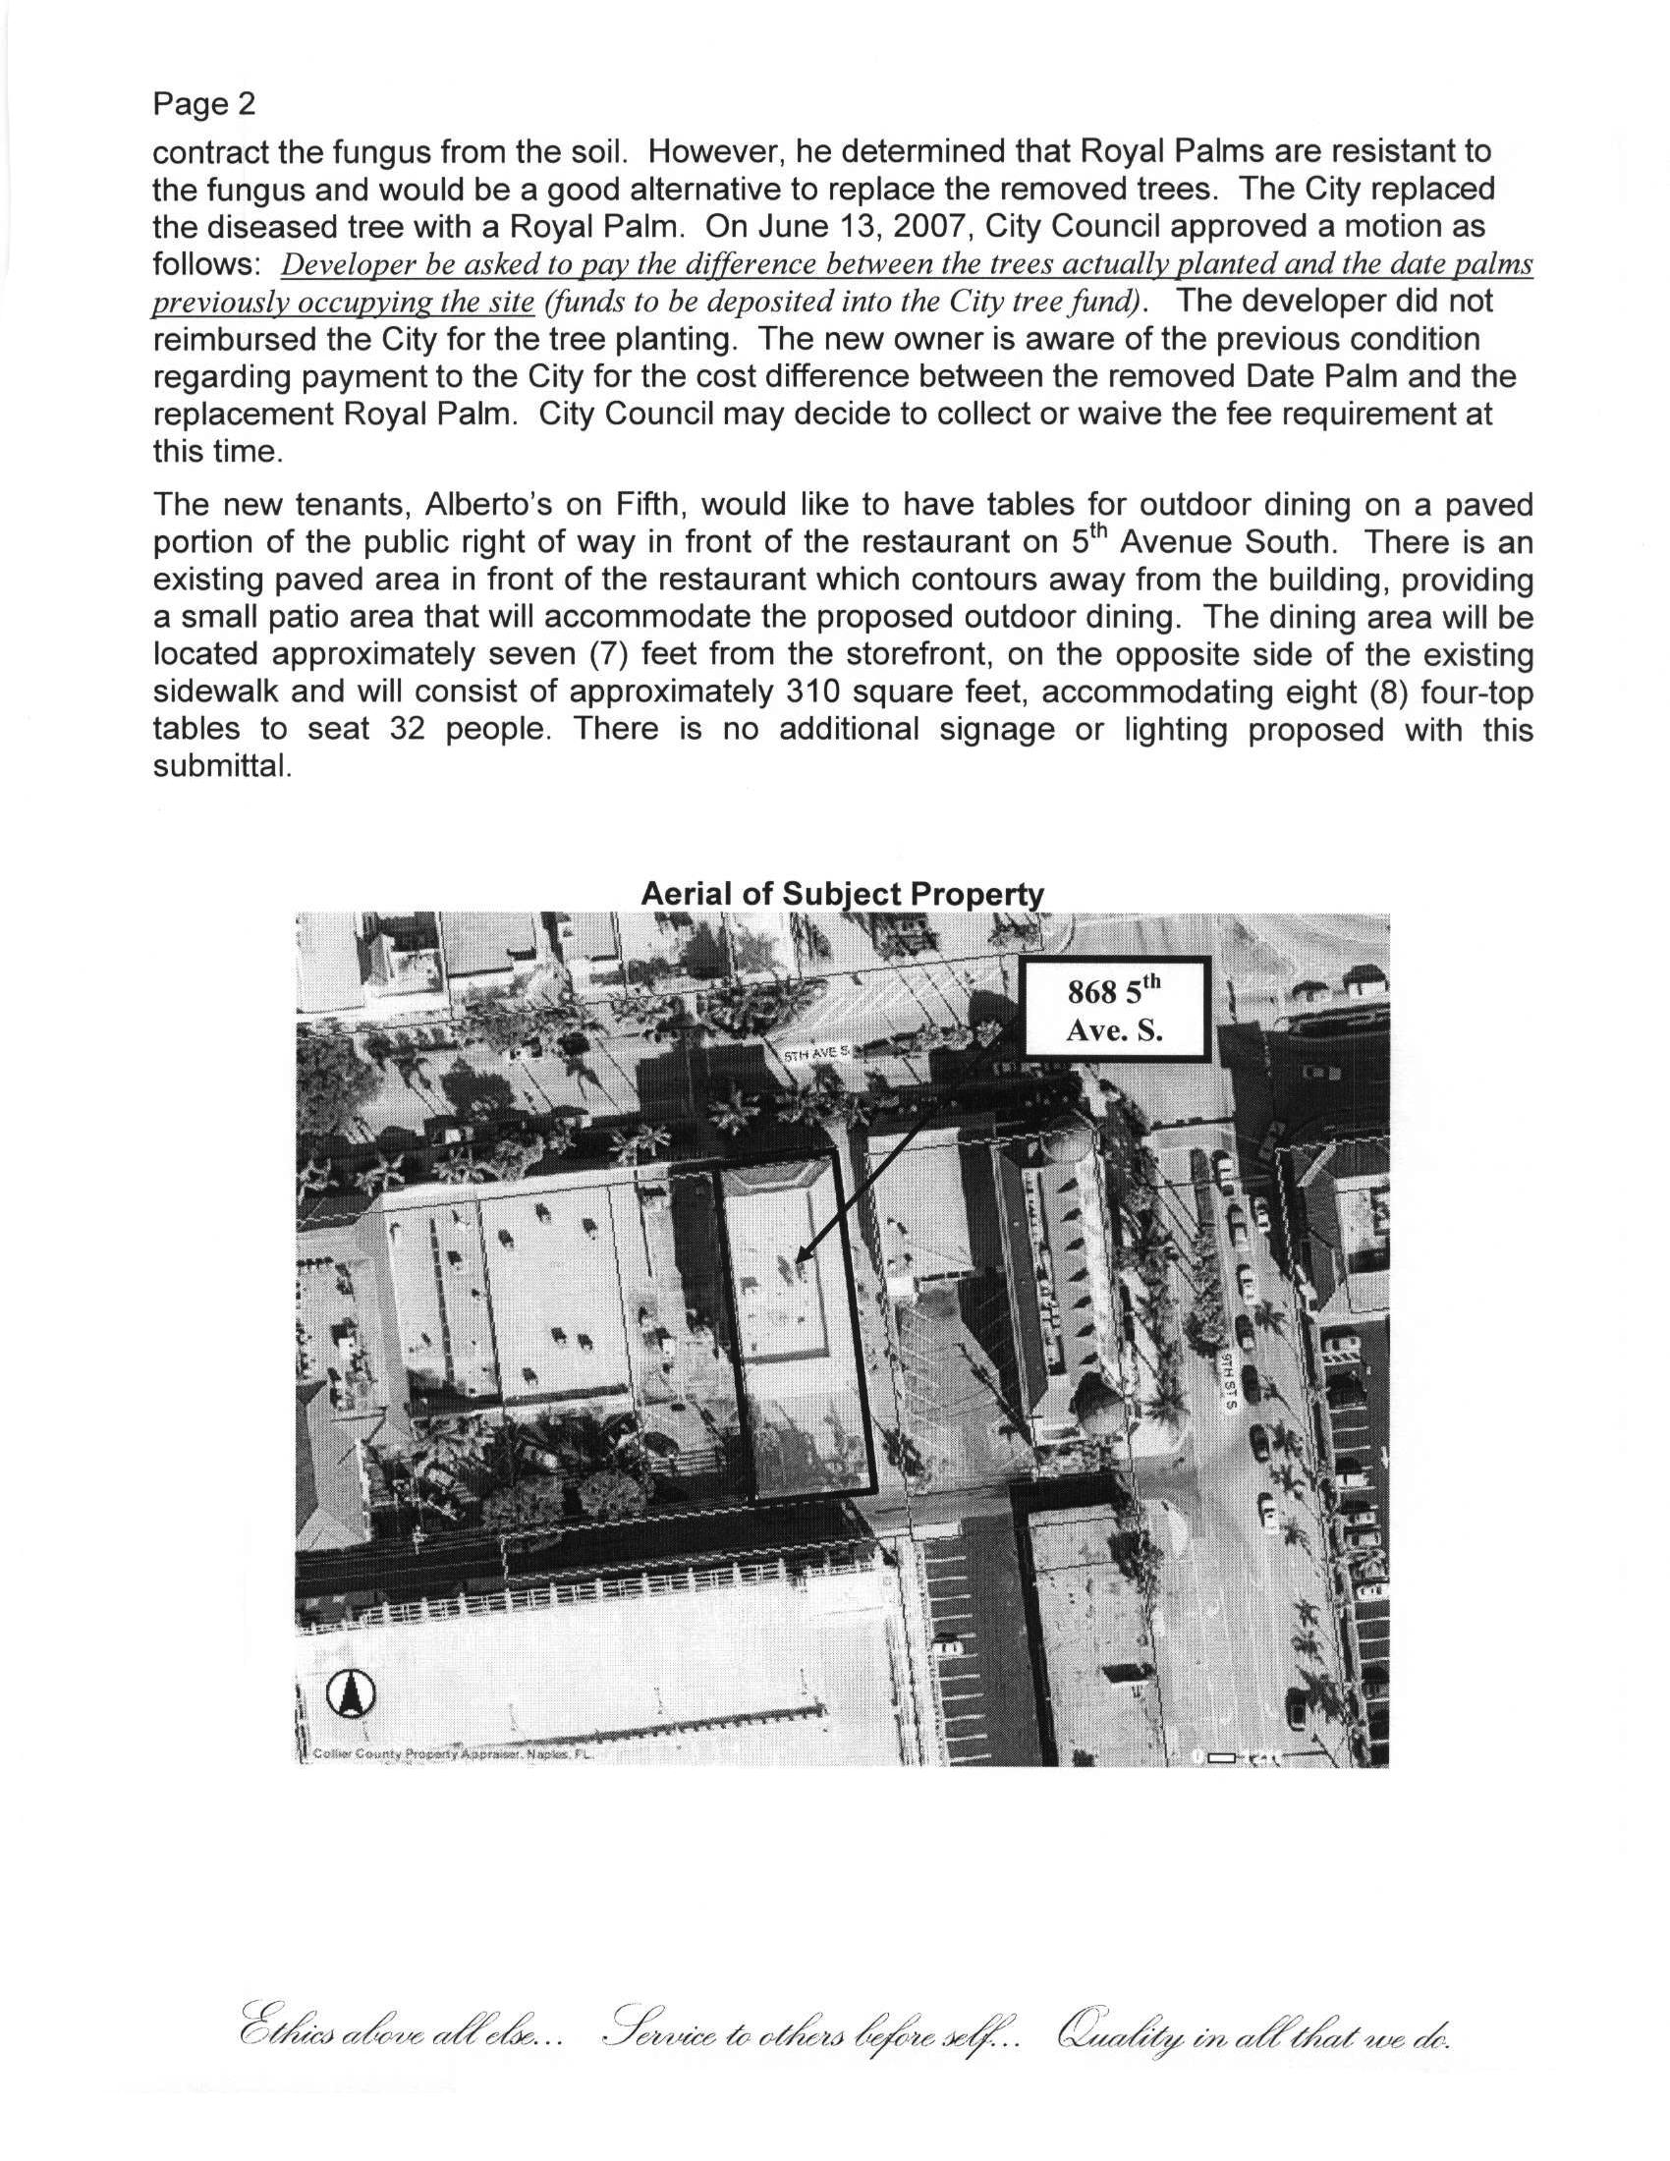
Attachment 3 / Page 1 of 1
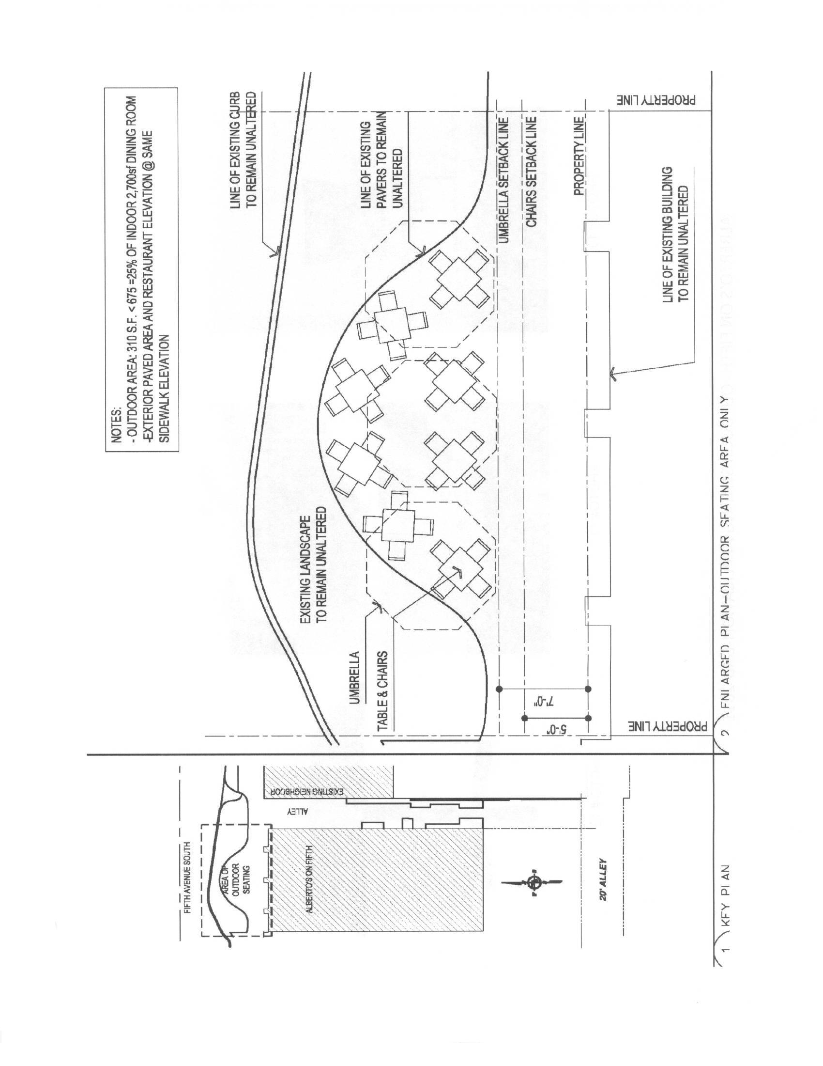
Attachment 4 / Page 1 of 2
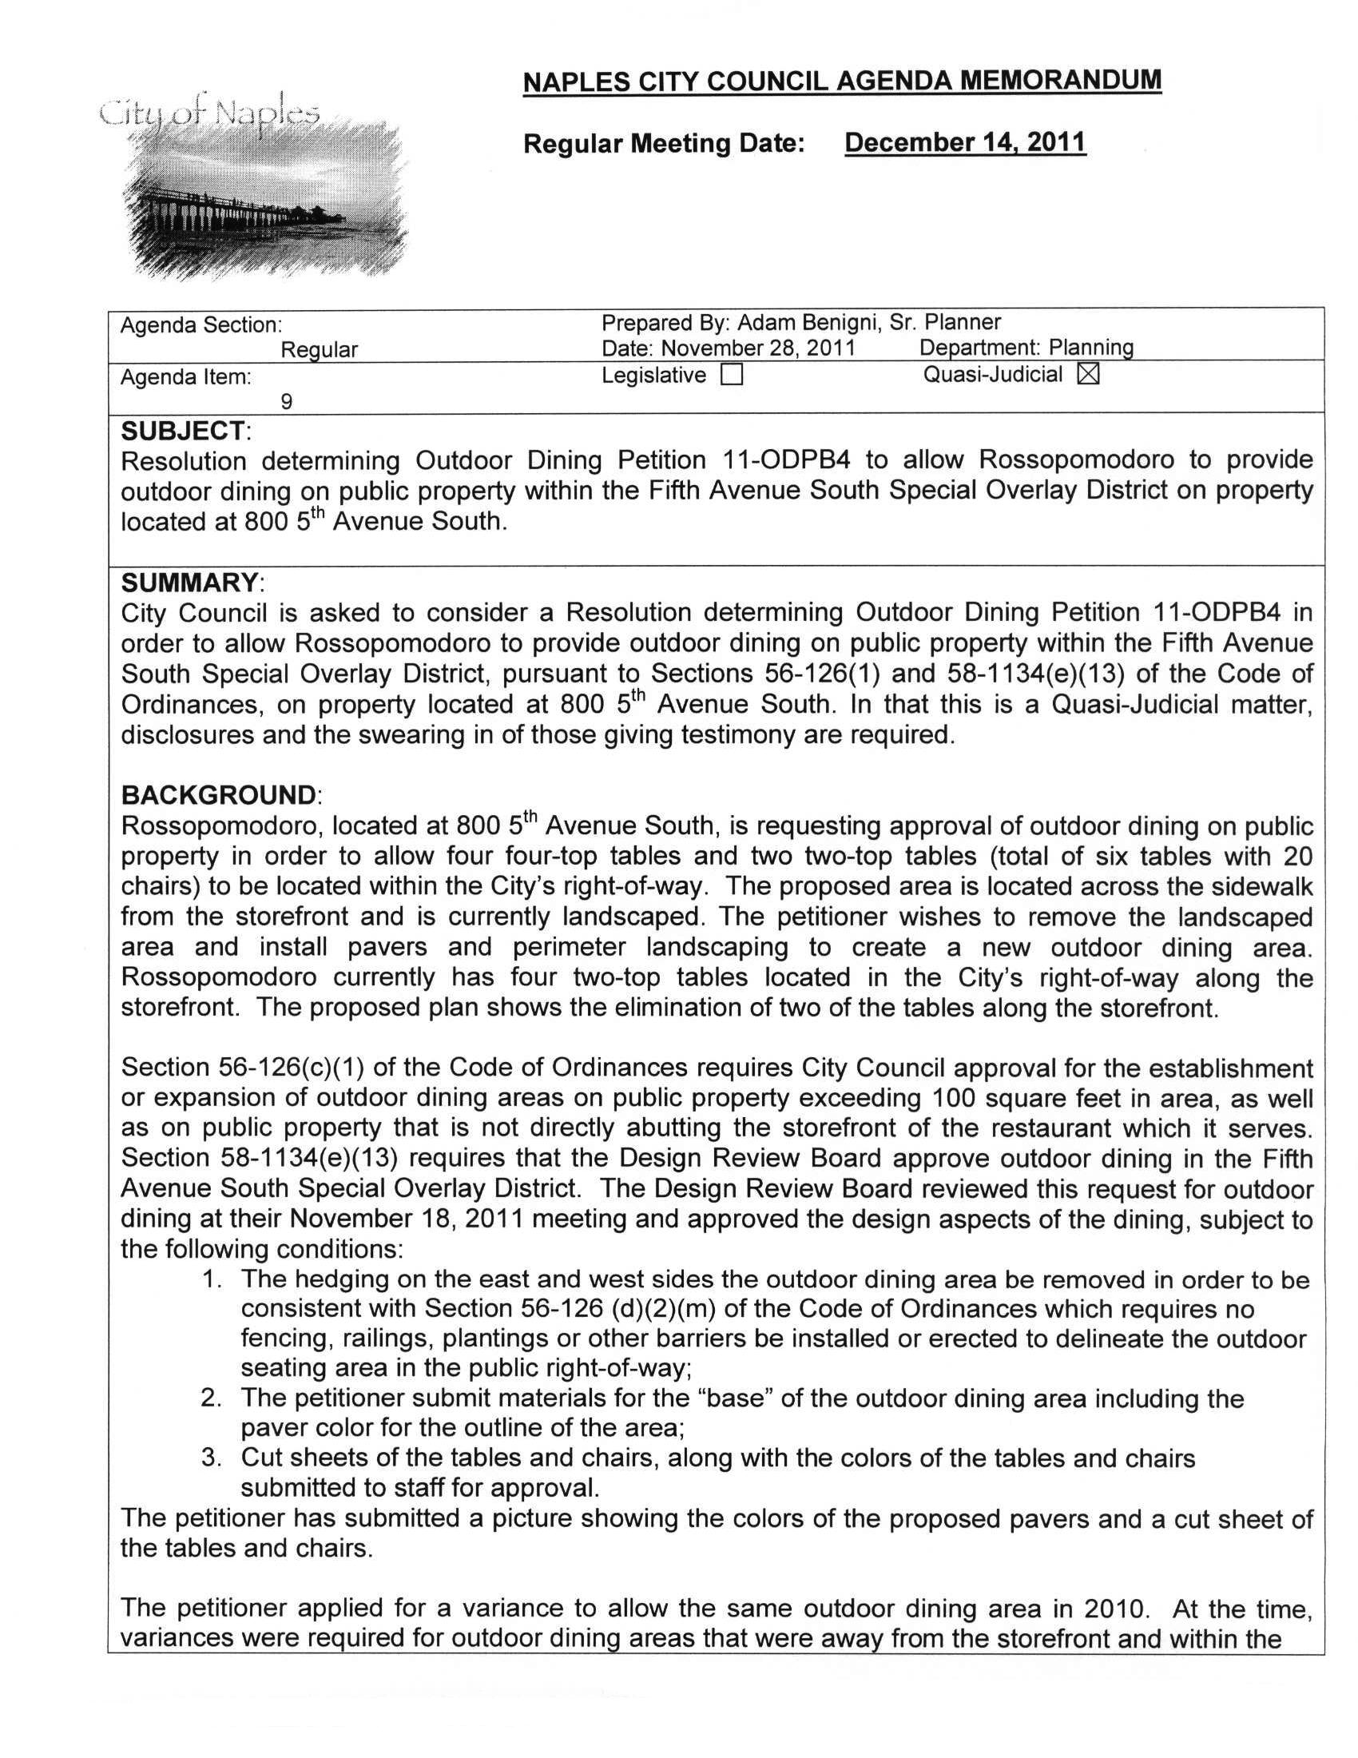
Attachment 4 / Page 2 of 2
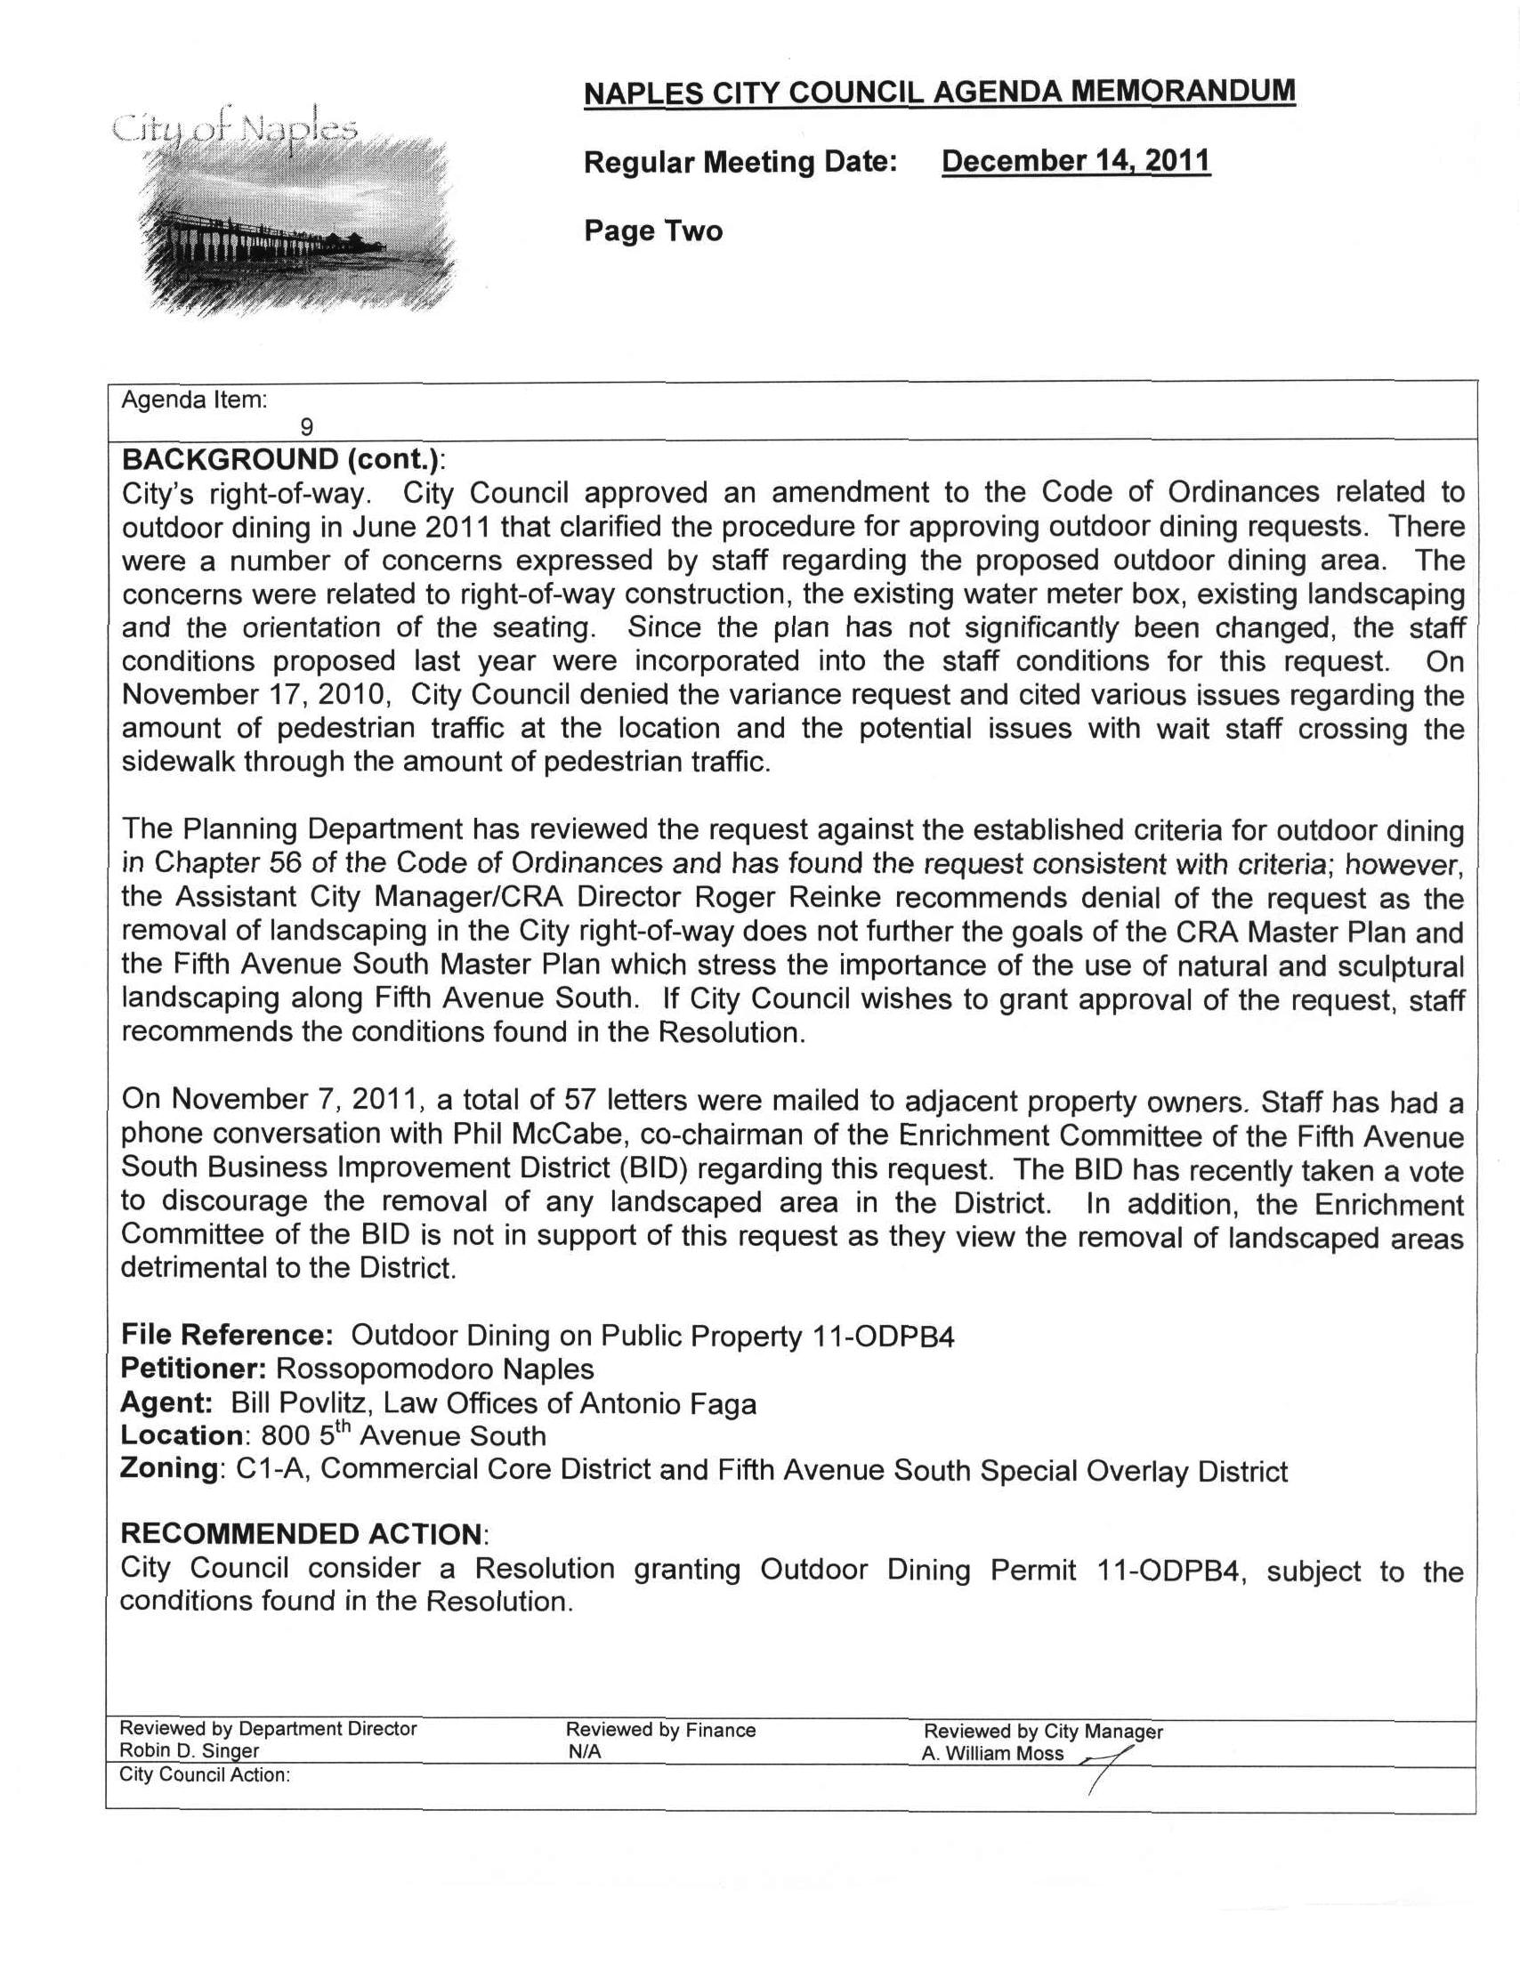
Attachment 5 / Page 1 of 1
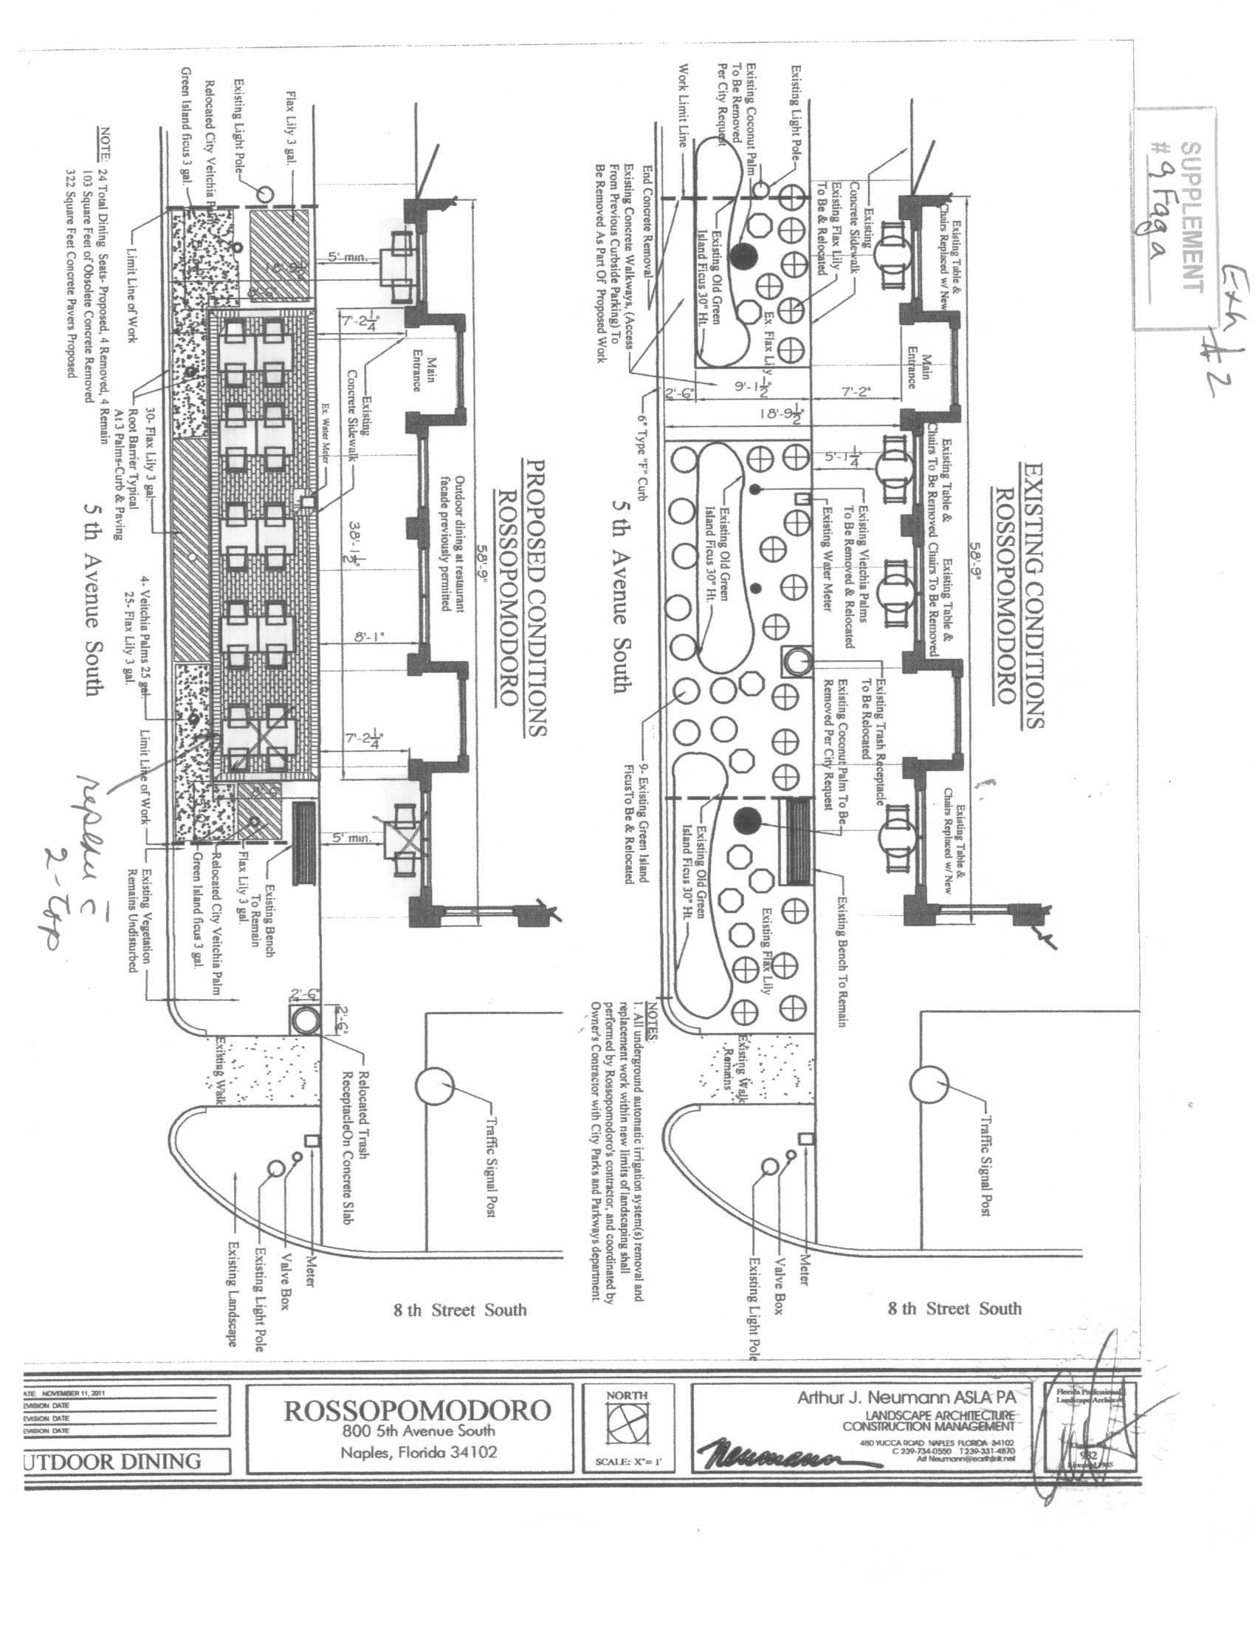
Attachment 6 / Page 1 of 1
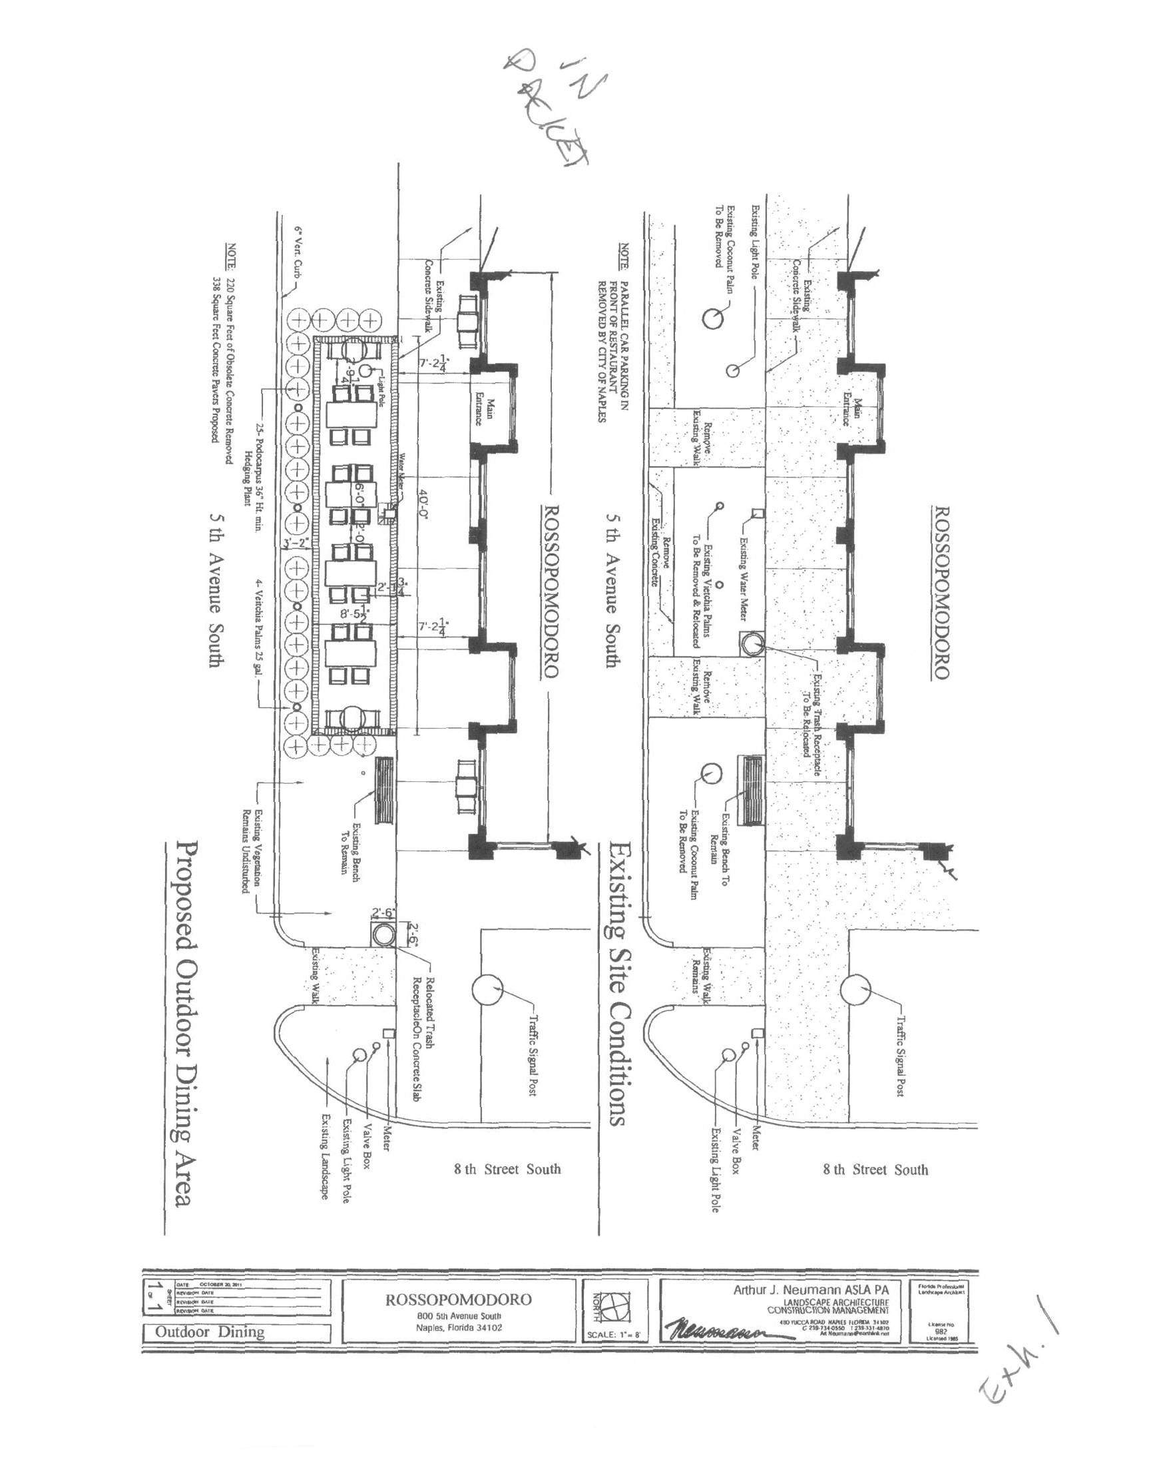
Attachment 7 / Page 1 of 2
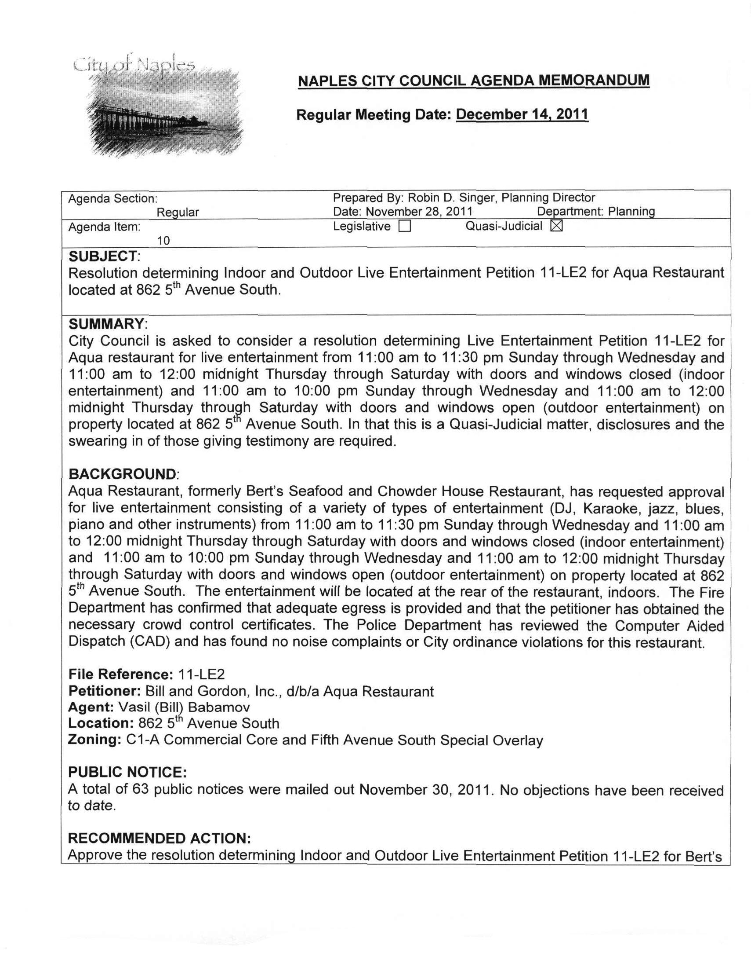
Attachment 7 / Page 2 of 2
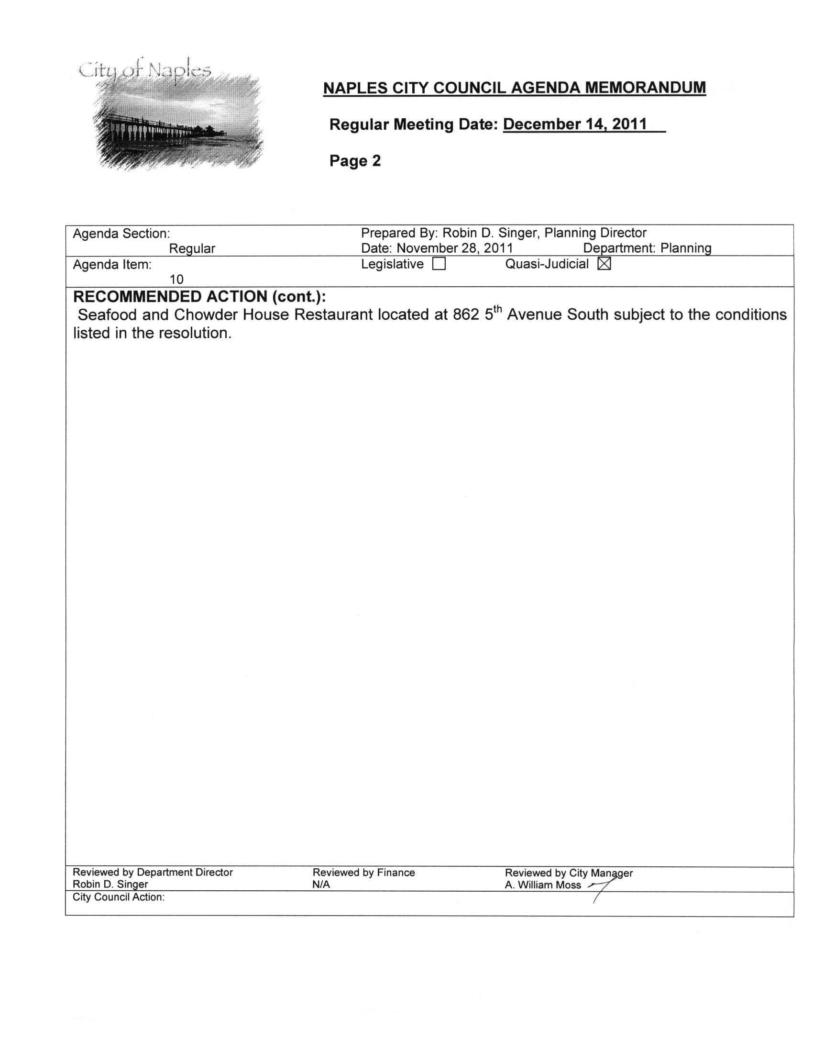
Attachment 8 / Page 1 of 1
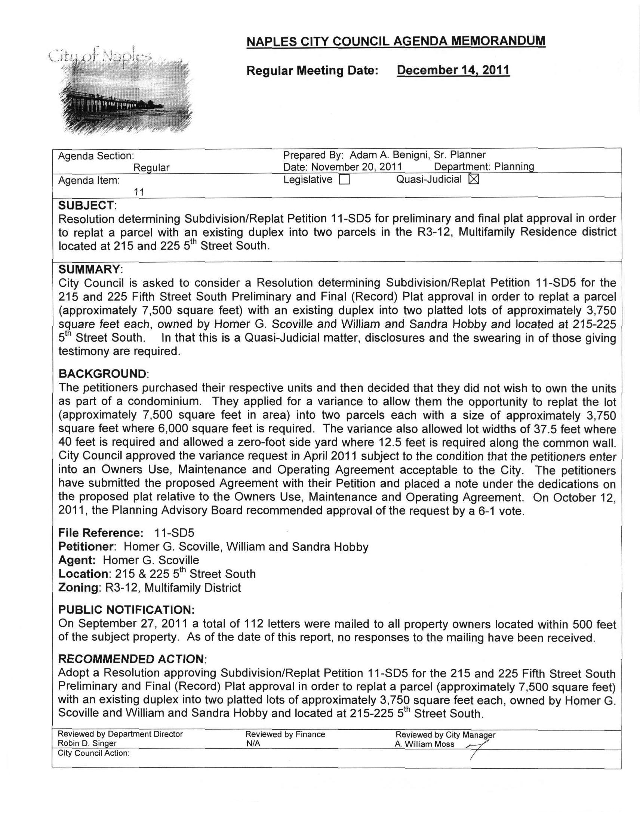
Attachment 9 / Page 1 of 2
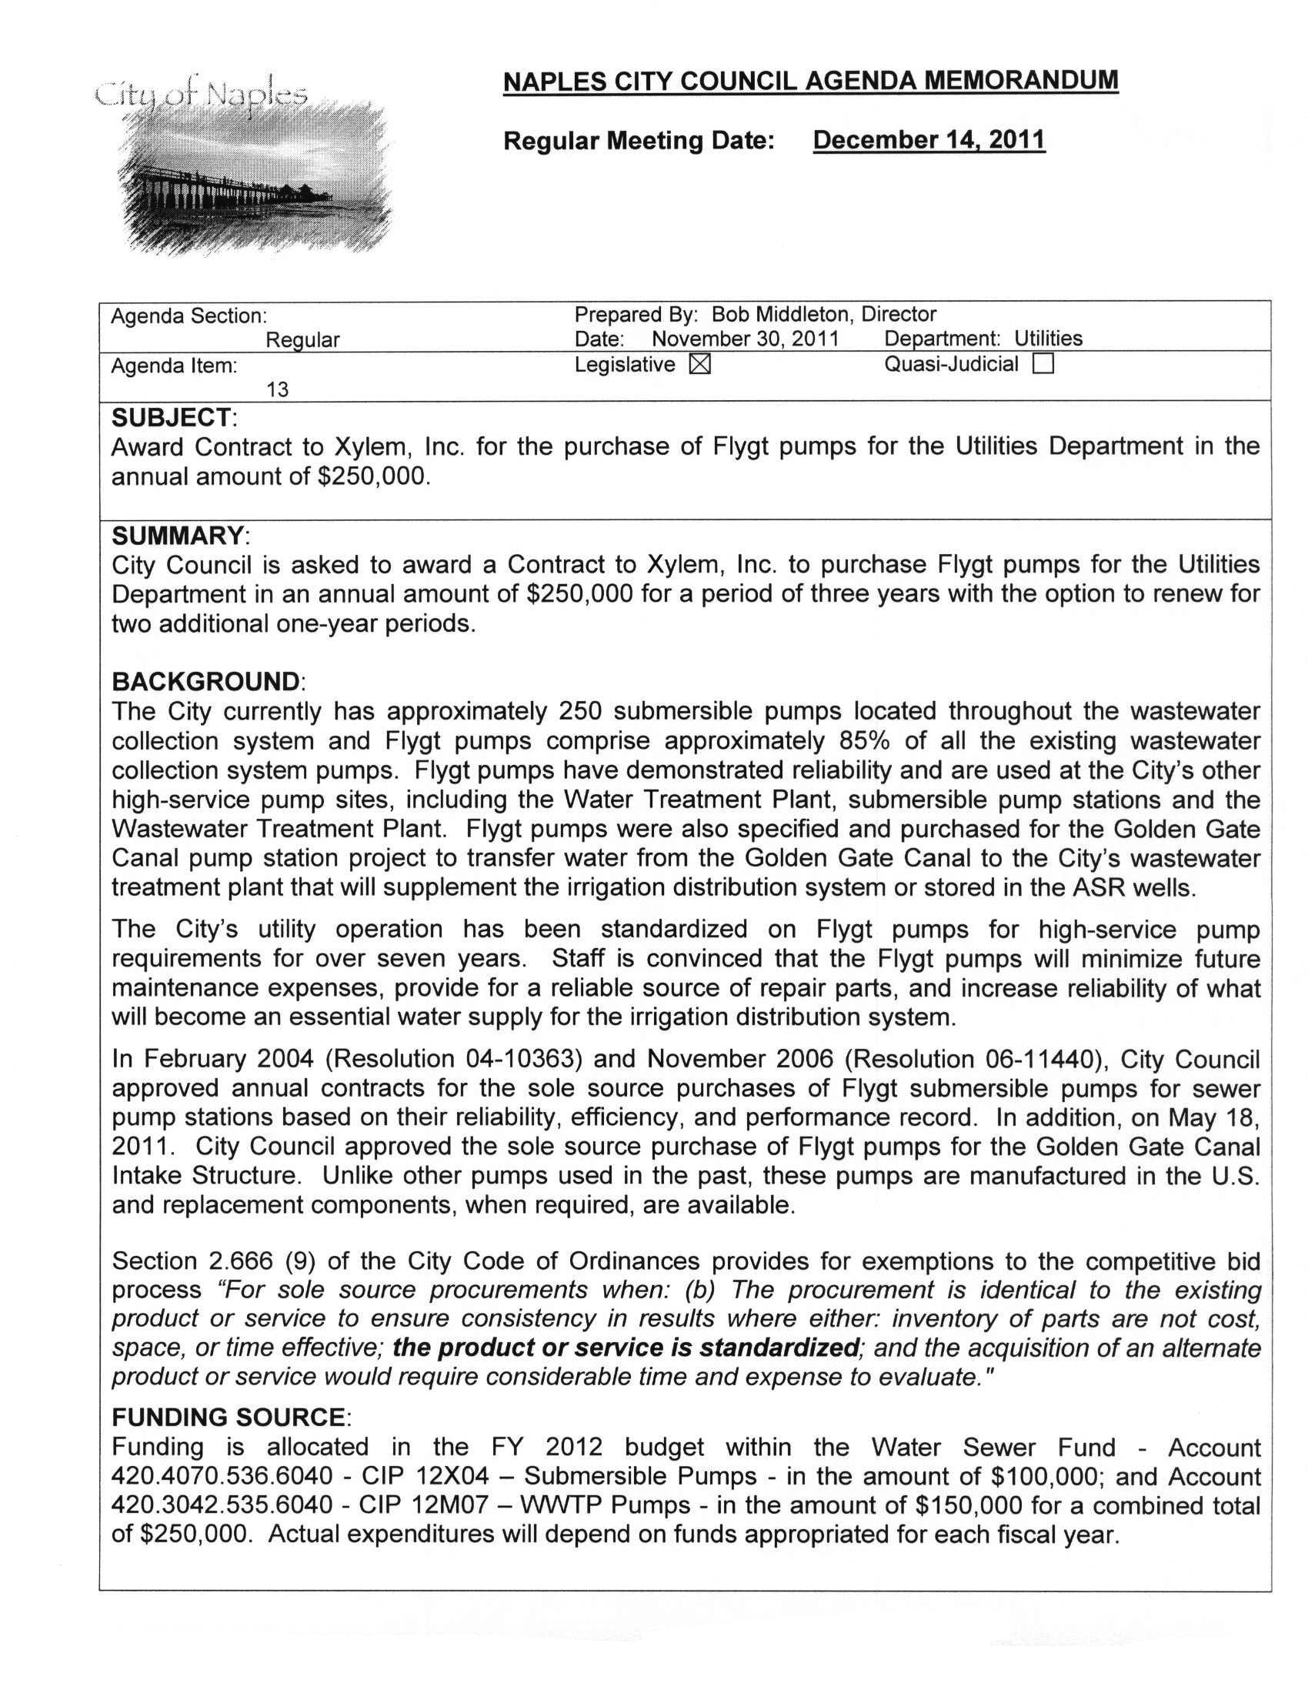
Attachment 9 / Page 2 of 2
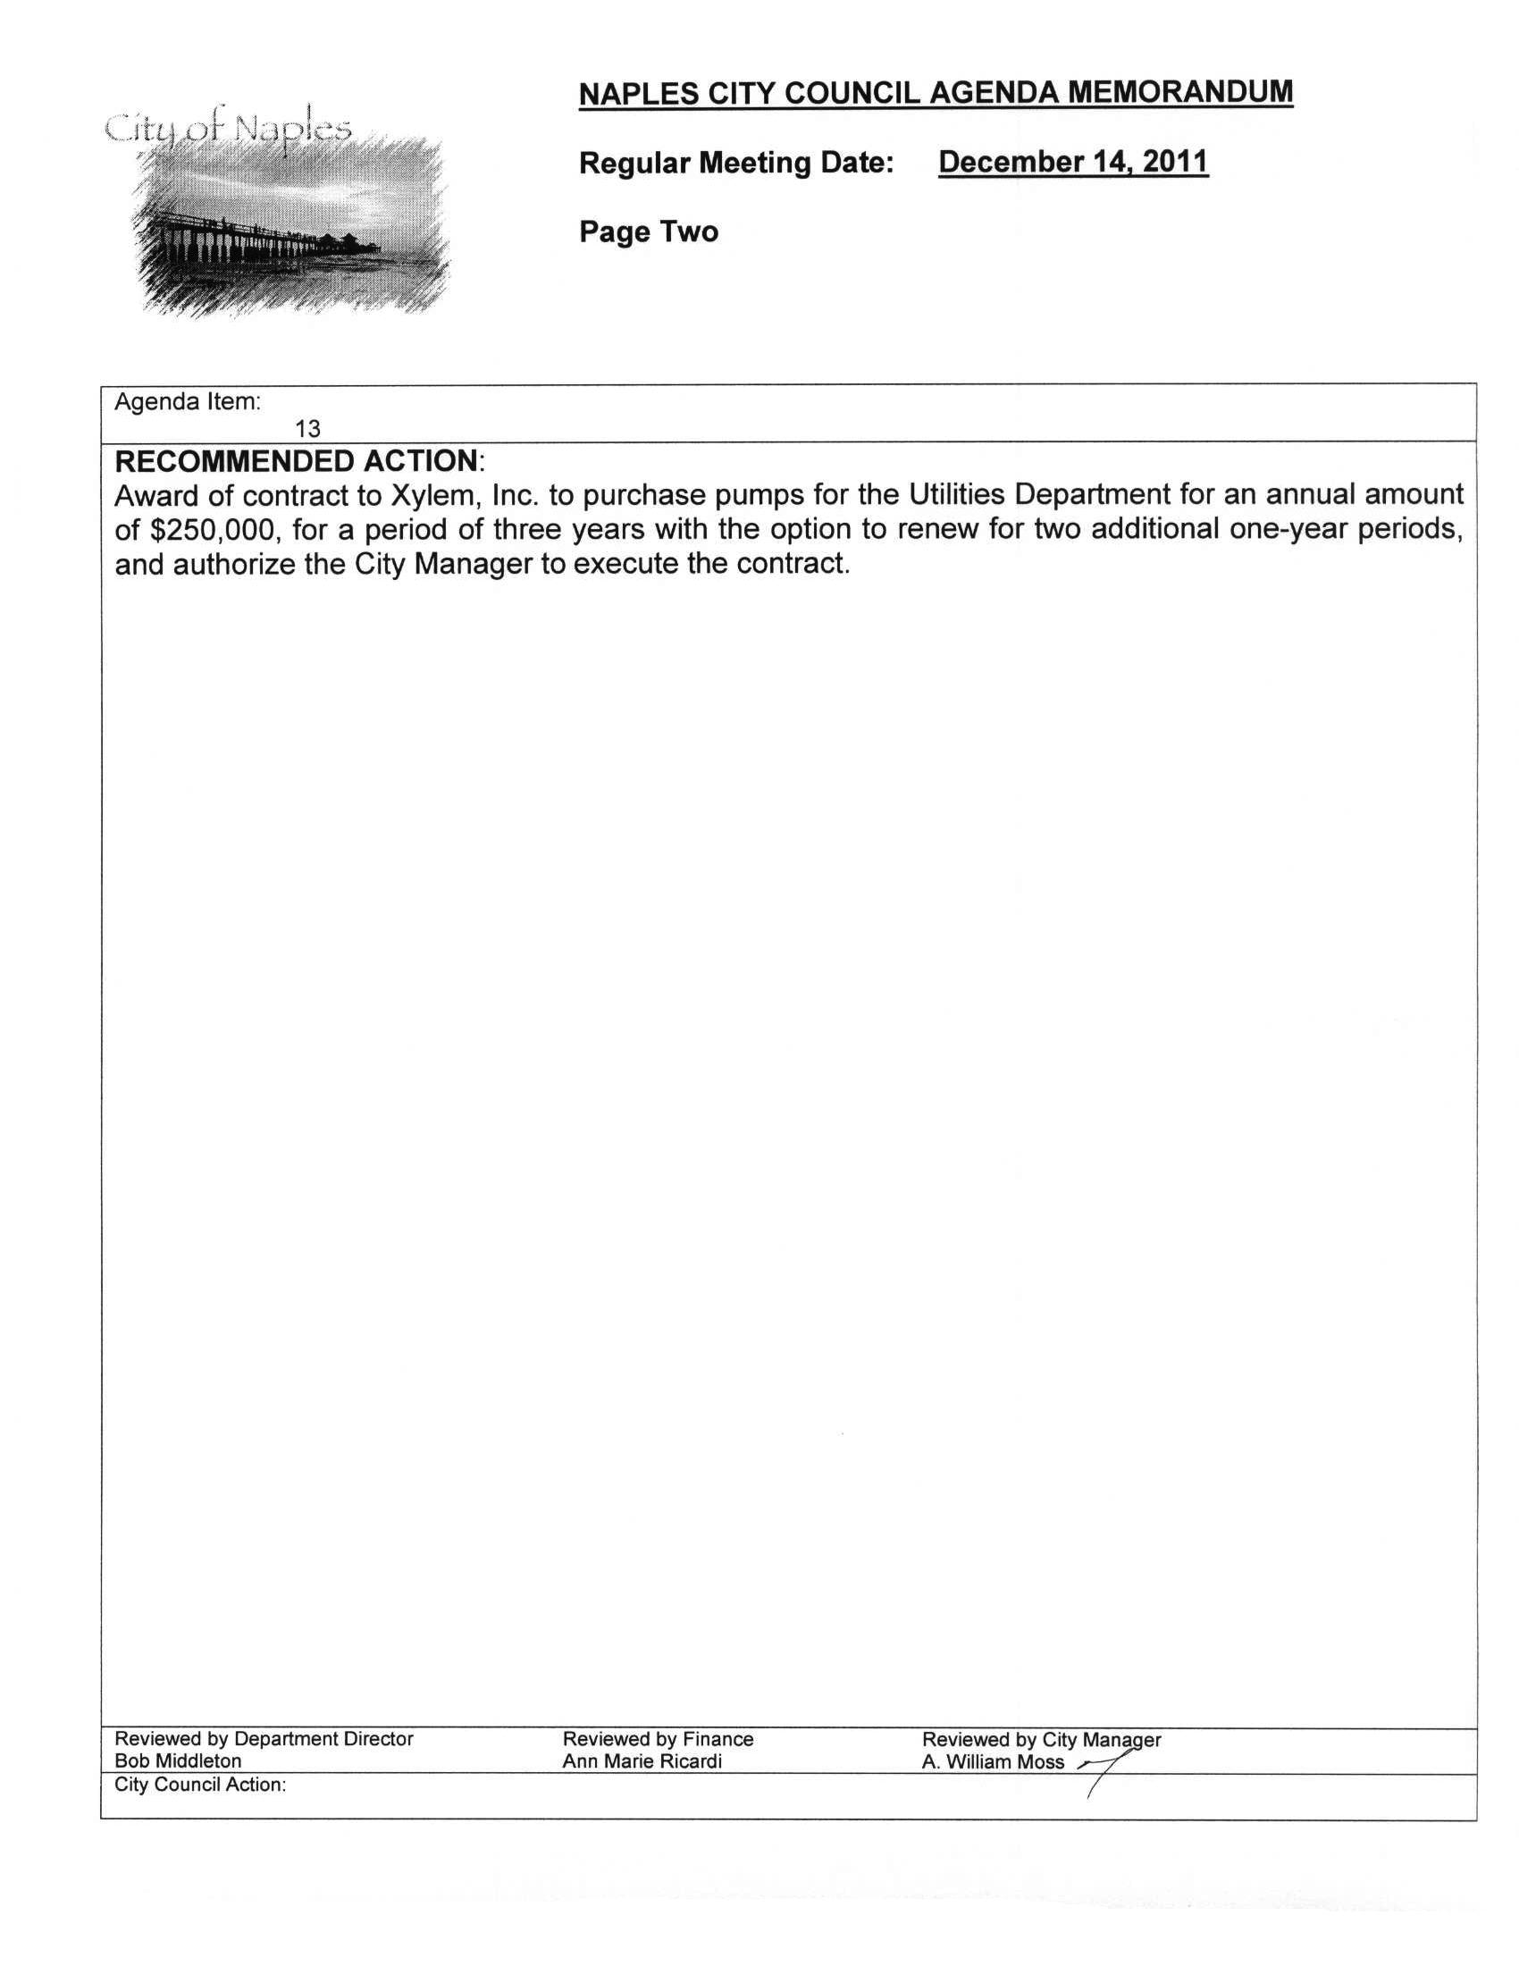
Attachment 10 / Page 1 of 4
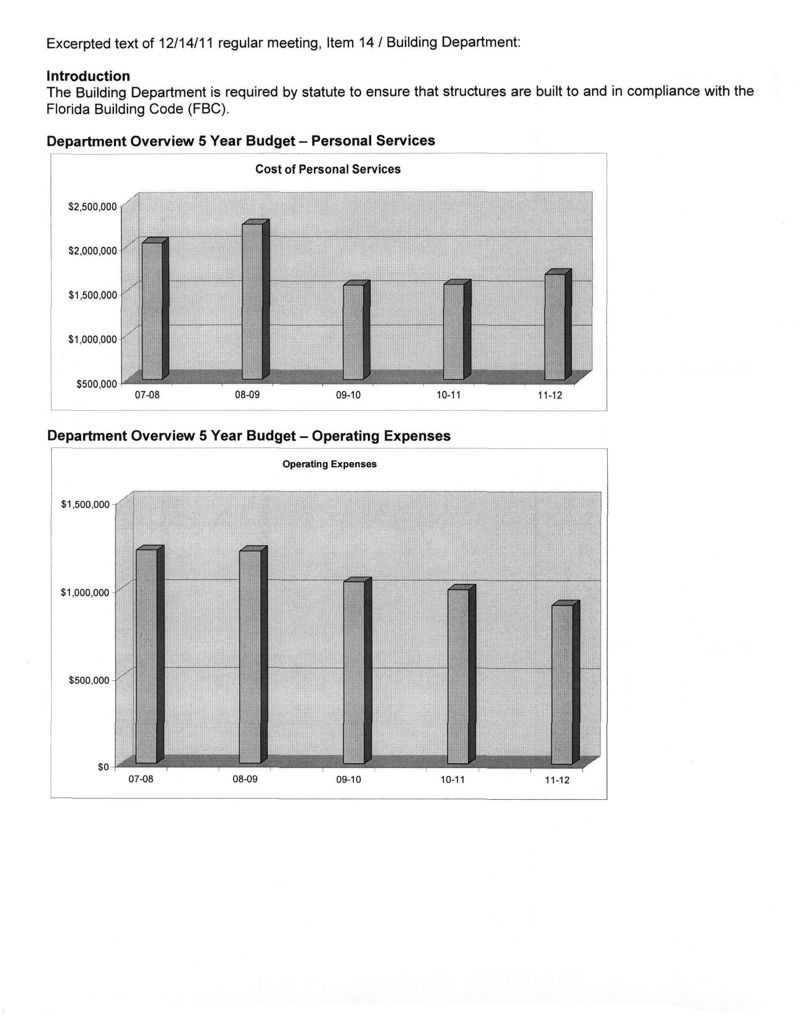
Attachment 10 / Page 2 of 4
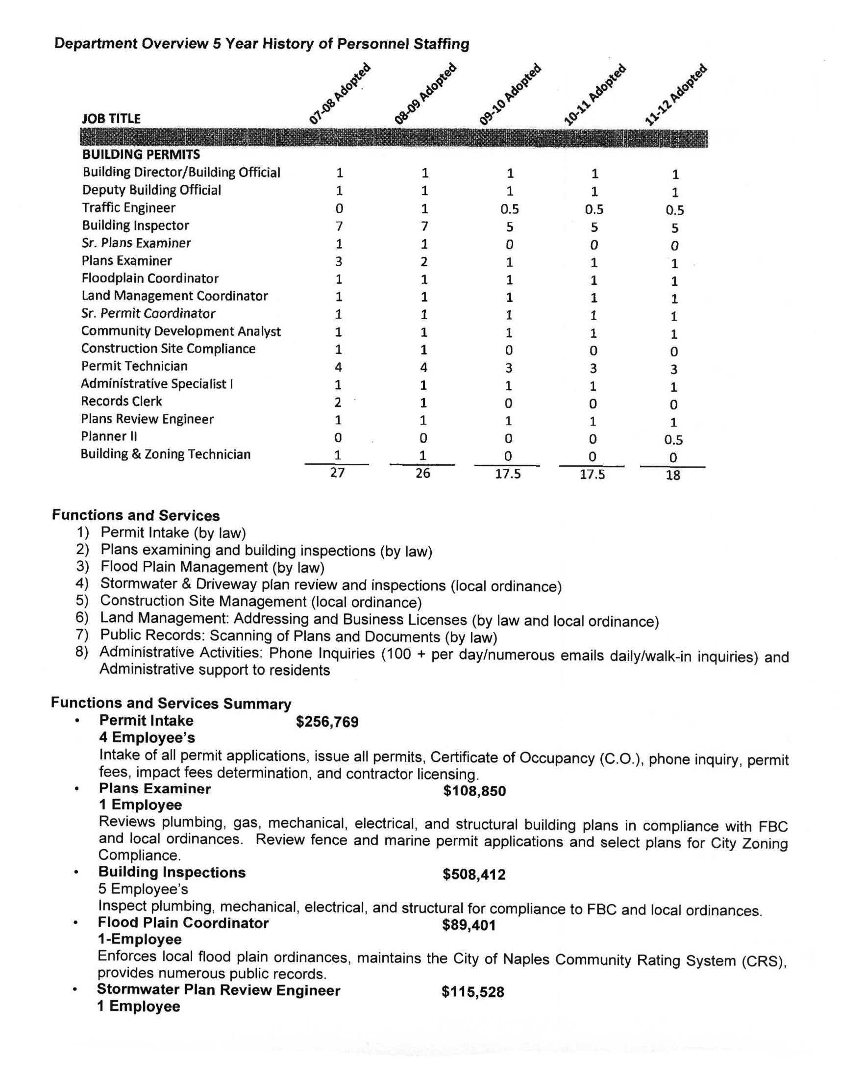
Attachment 10 / Page 3 of 4
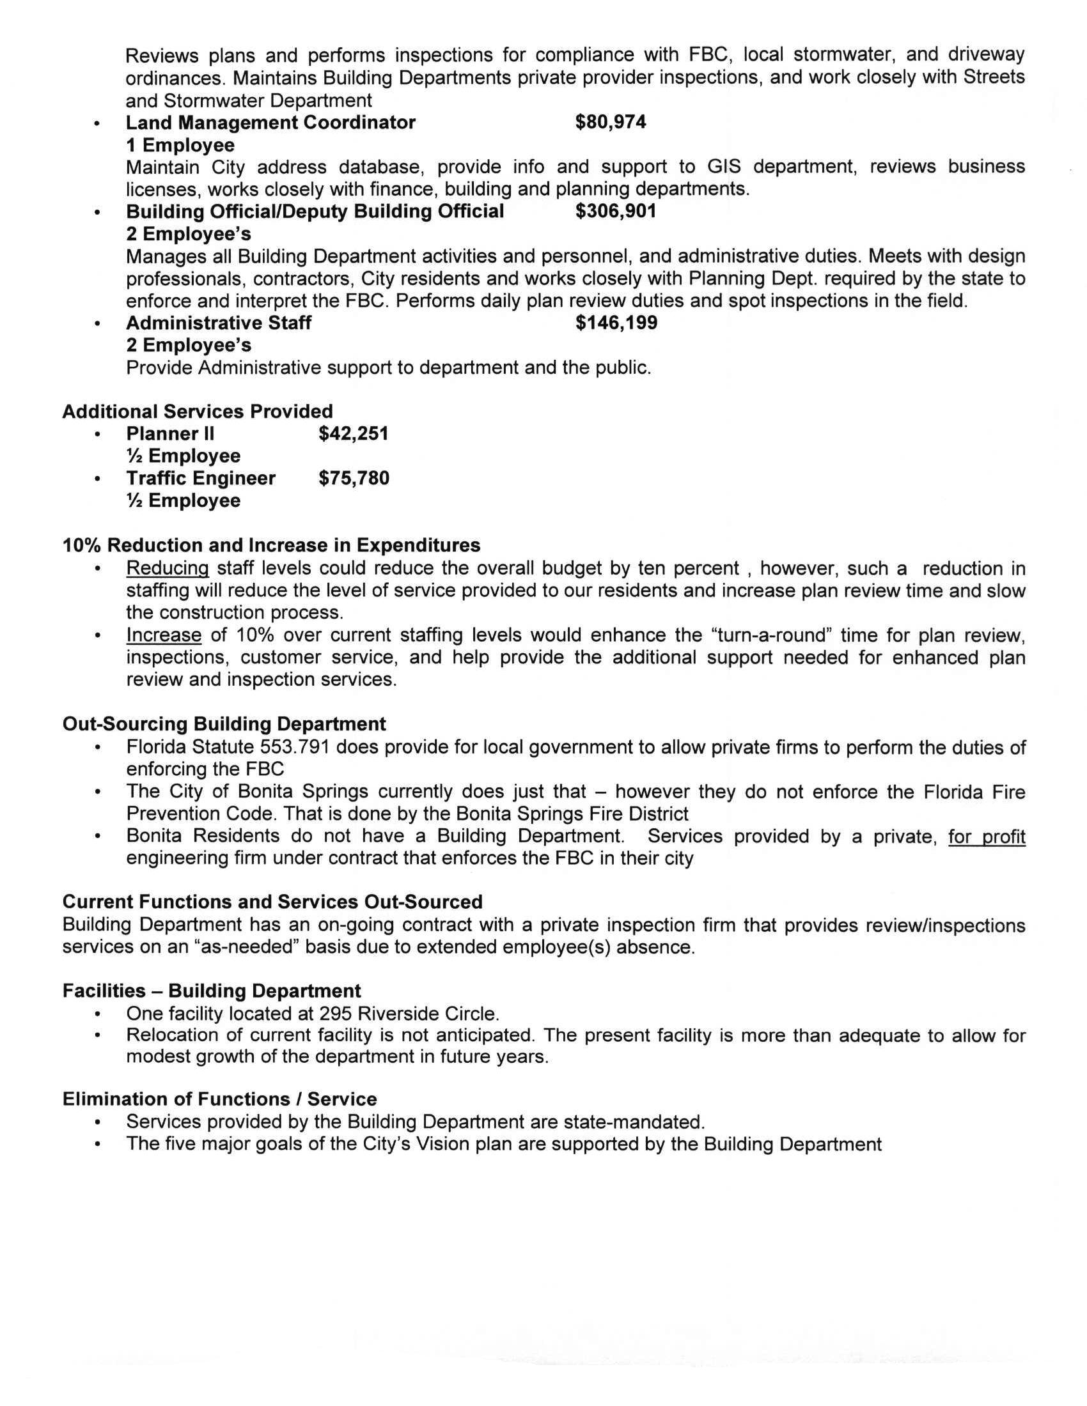
Attachment 10 / Page 4 of 4
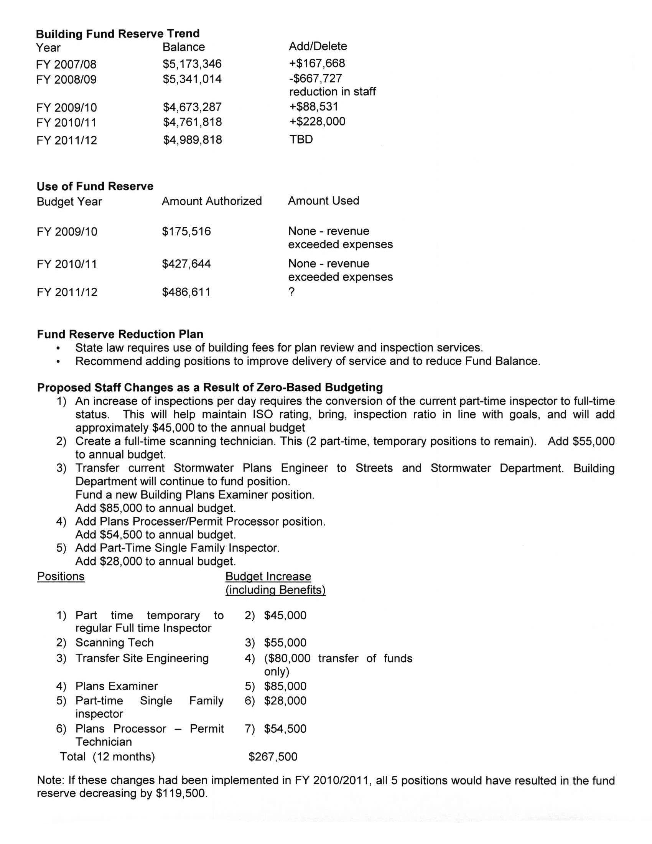
Attachment 11 / Page 1 of 4
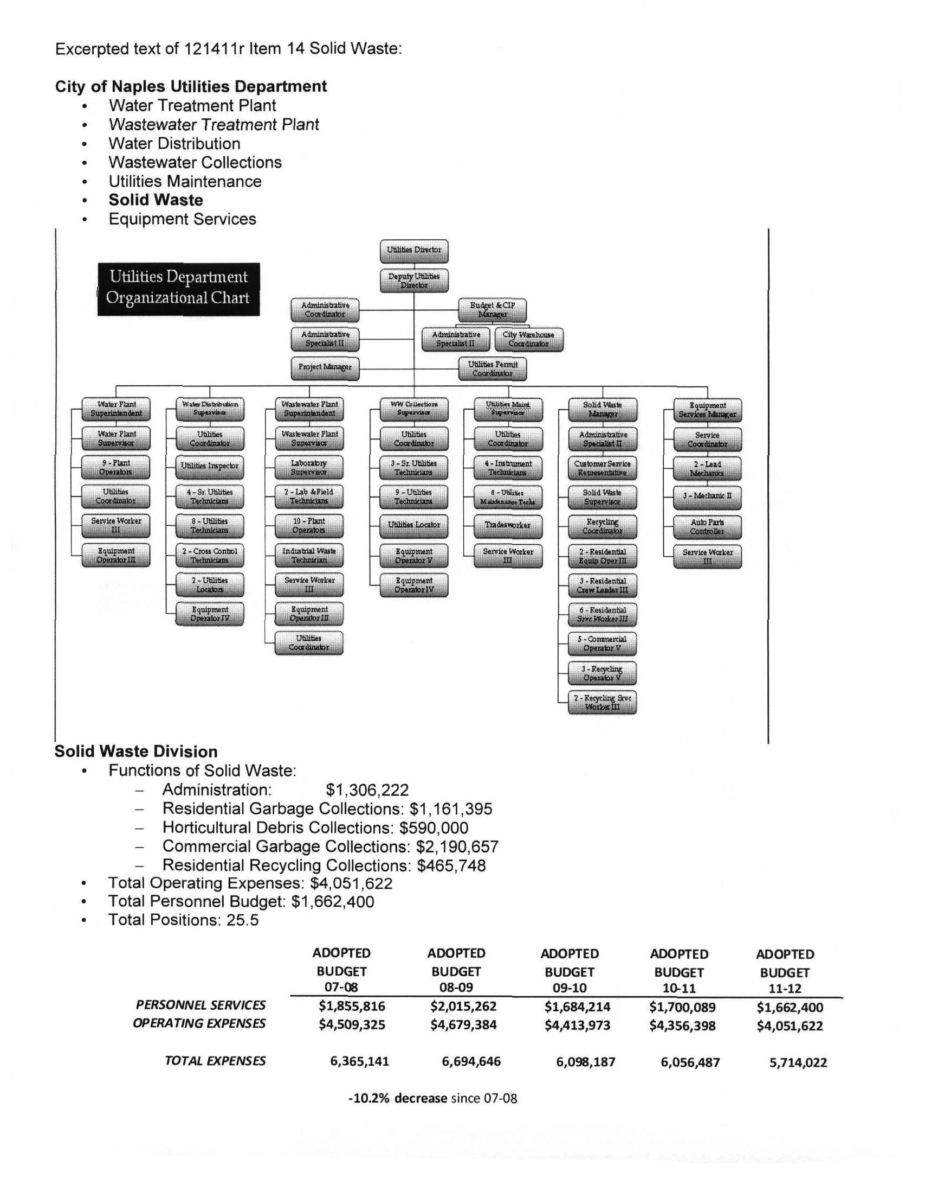
Attachment 11 / Page 2 of 4
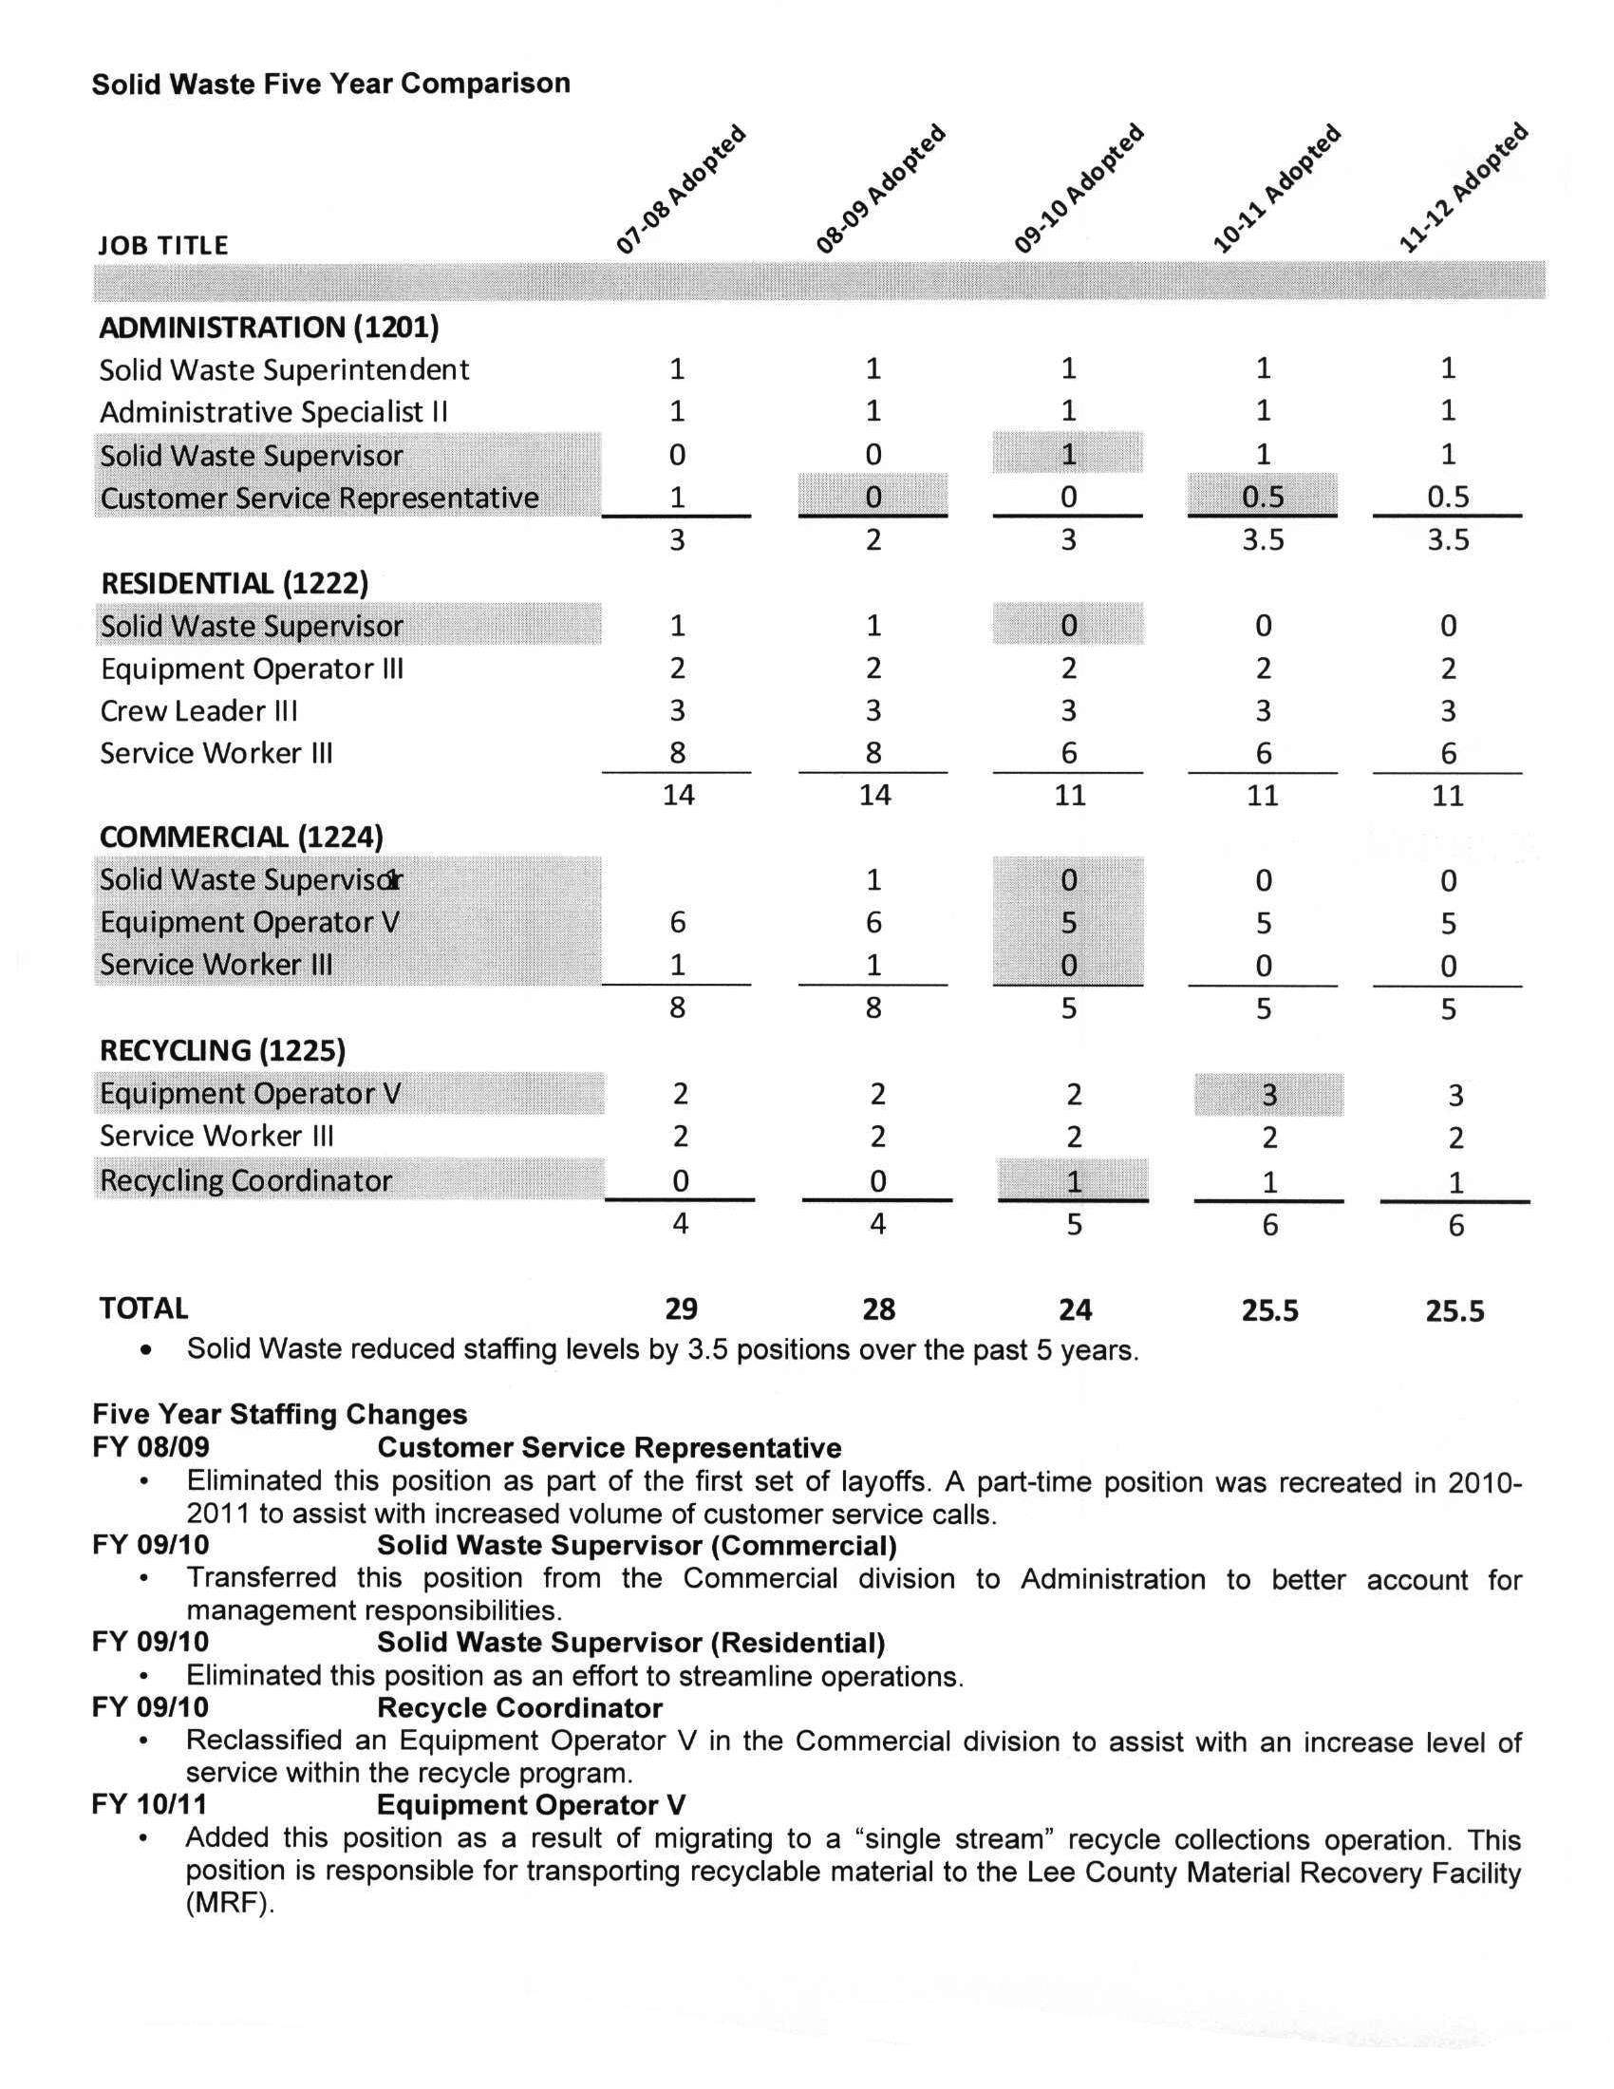
Attachment 11 / Page 3 of 4
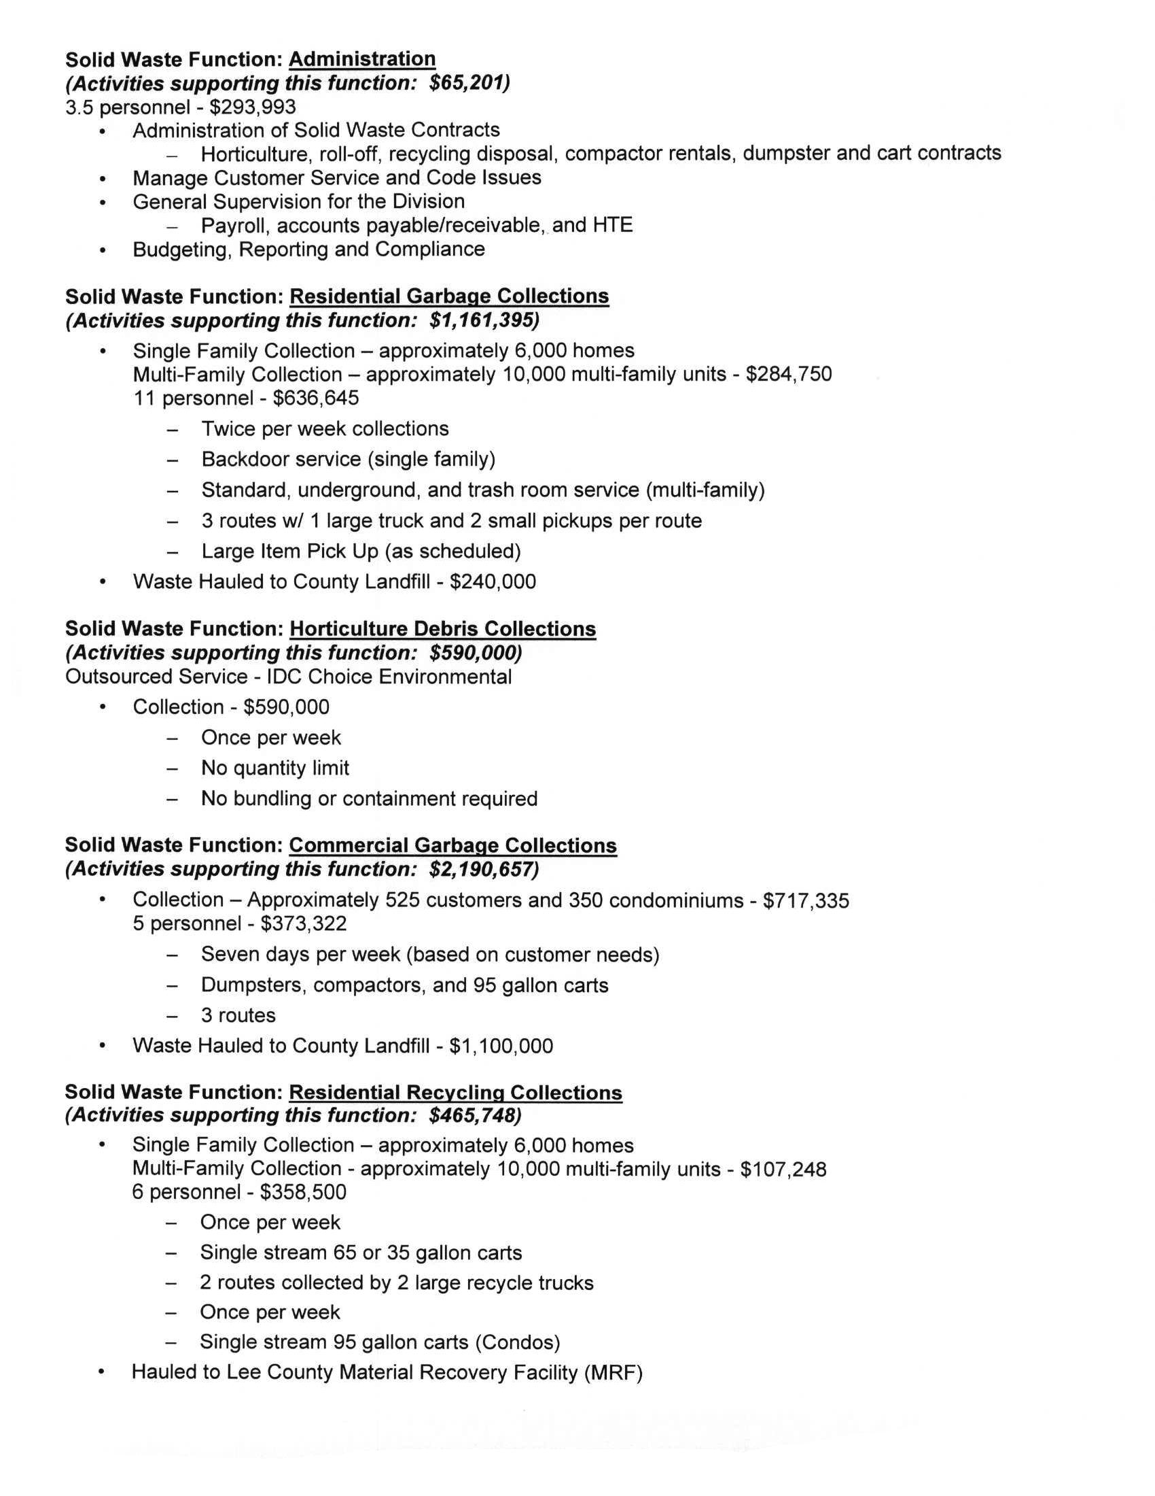
Attachment 11 / Page 4 of 4
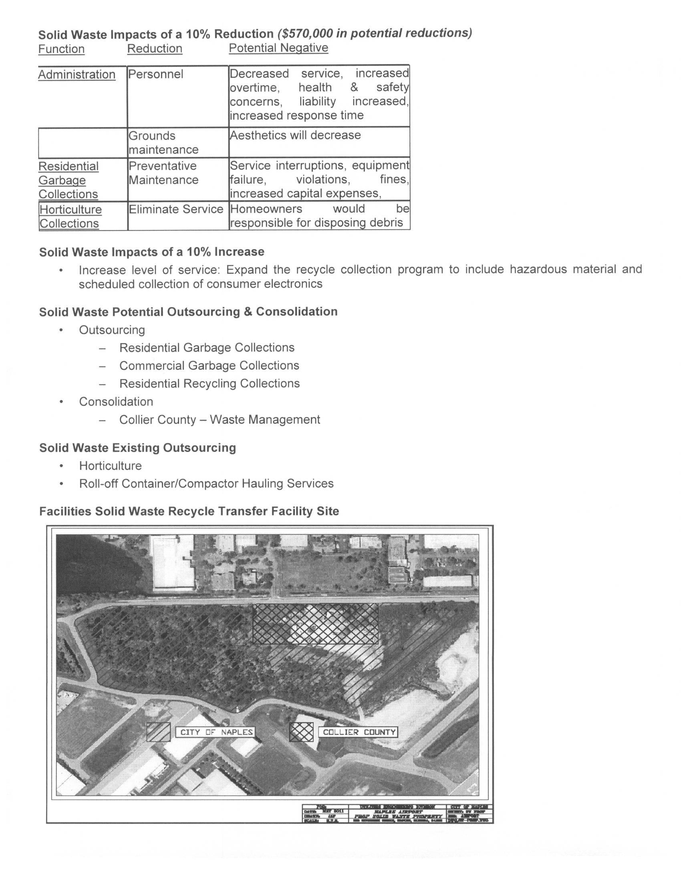
Attachment 12 / Page 1 of 4
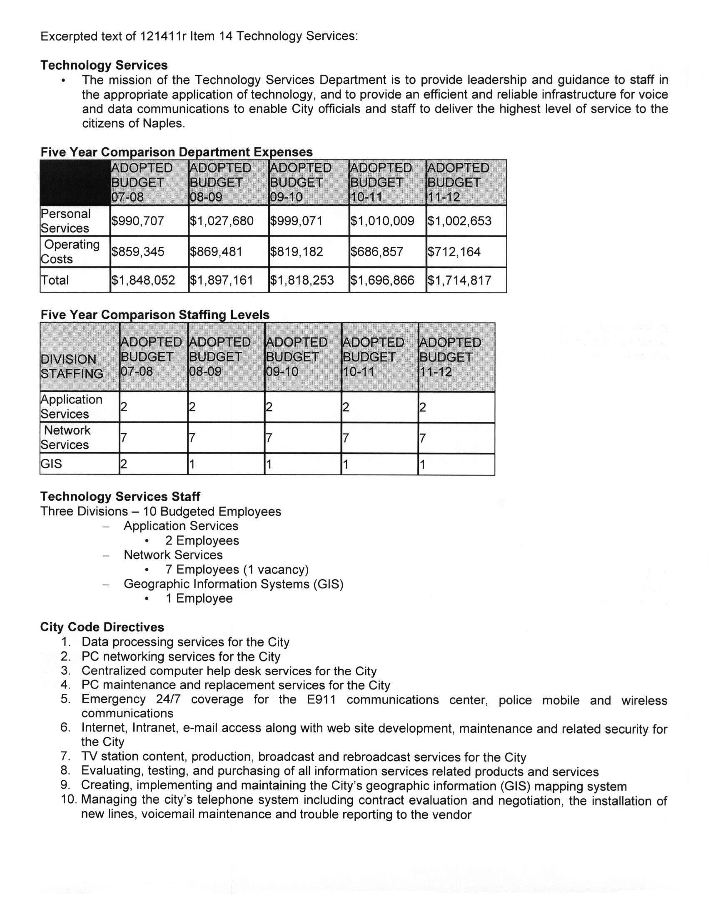
Attachment 12 / Page 2 of 4
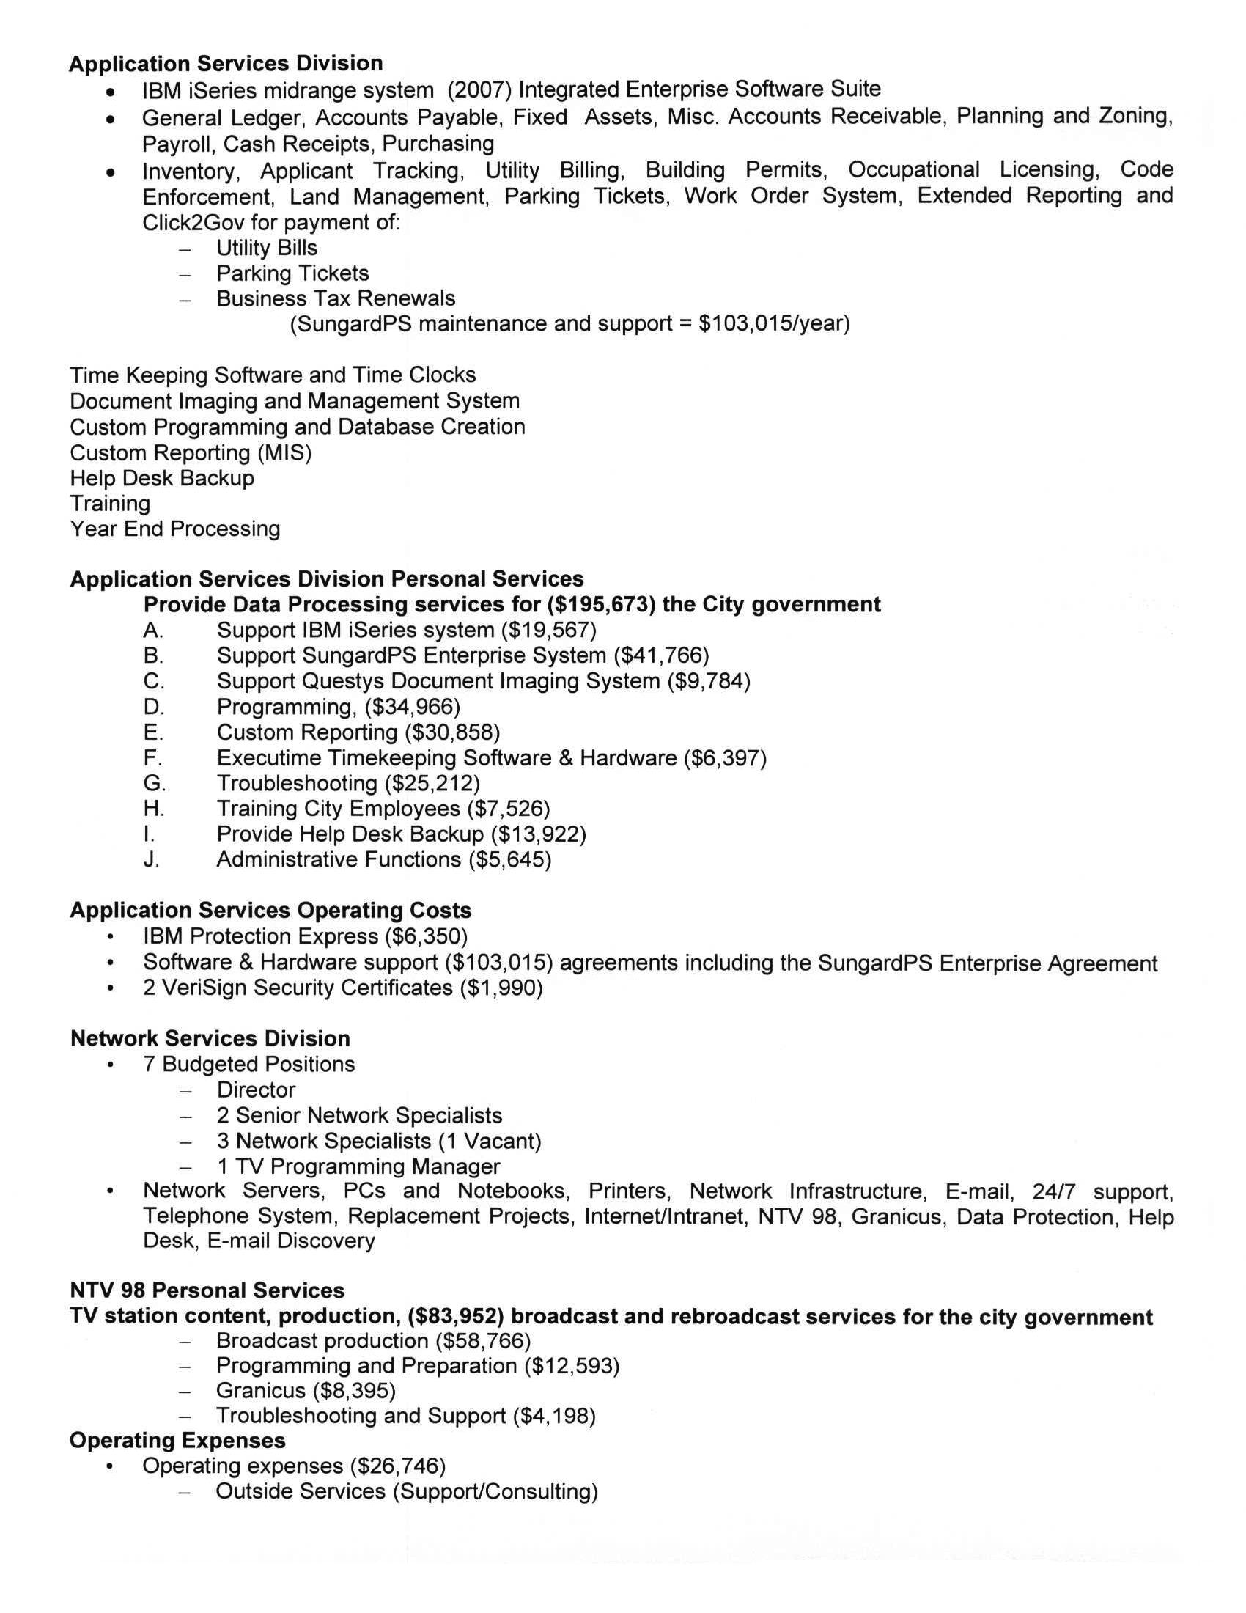
Attachment 12 / Page 3 of 4
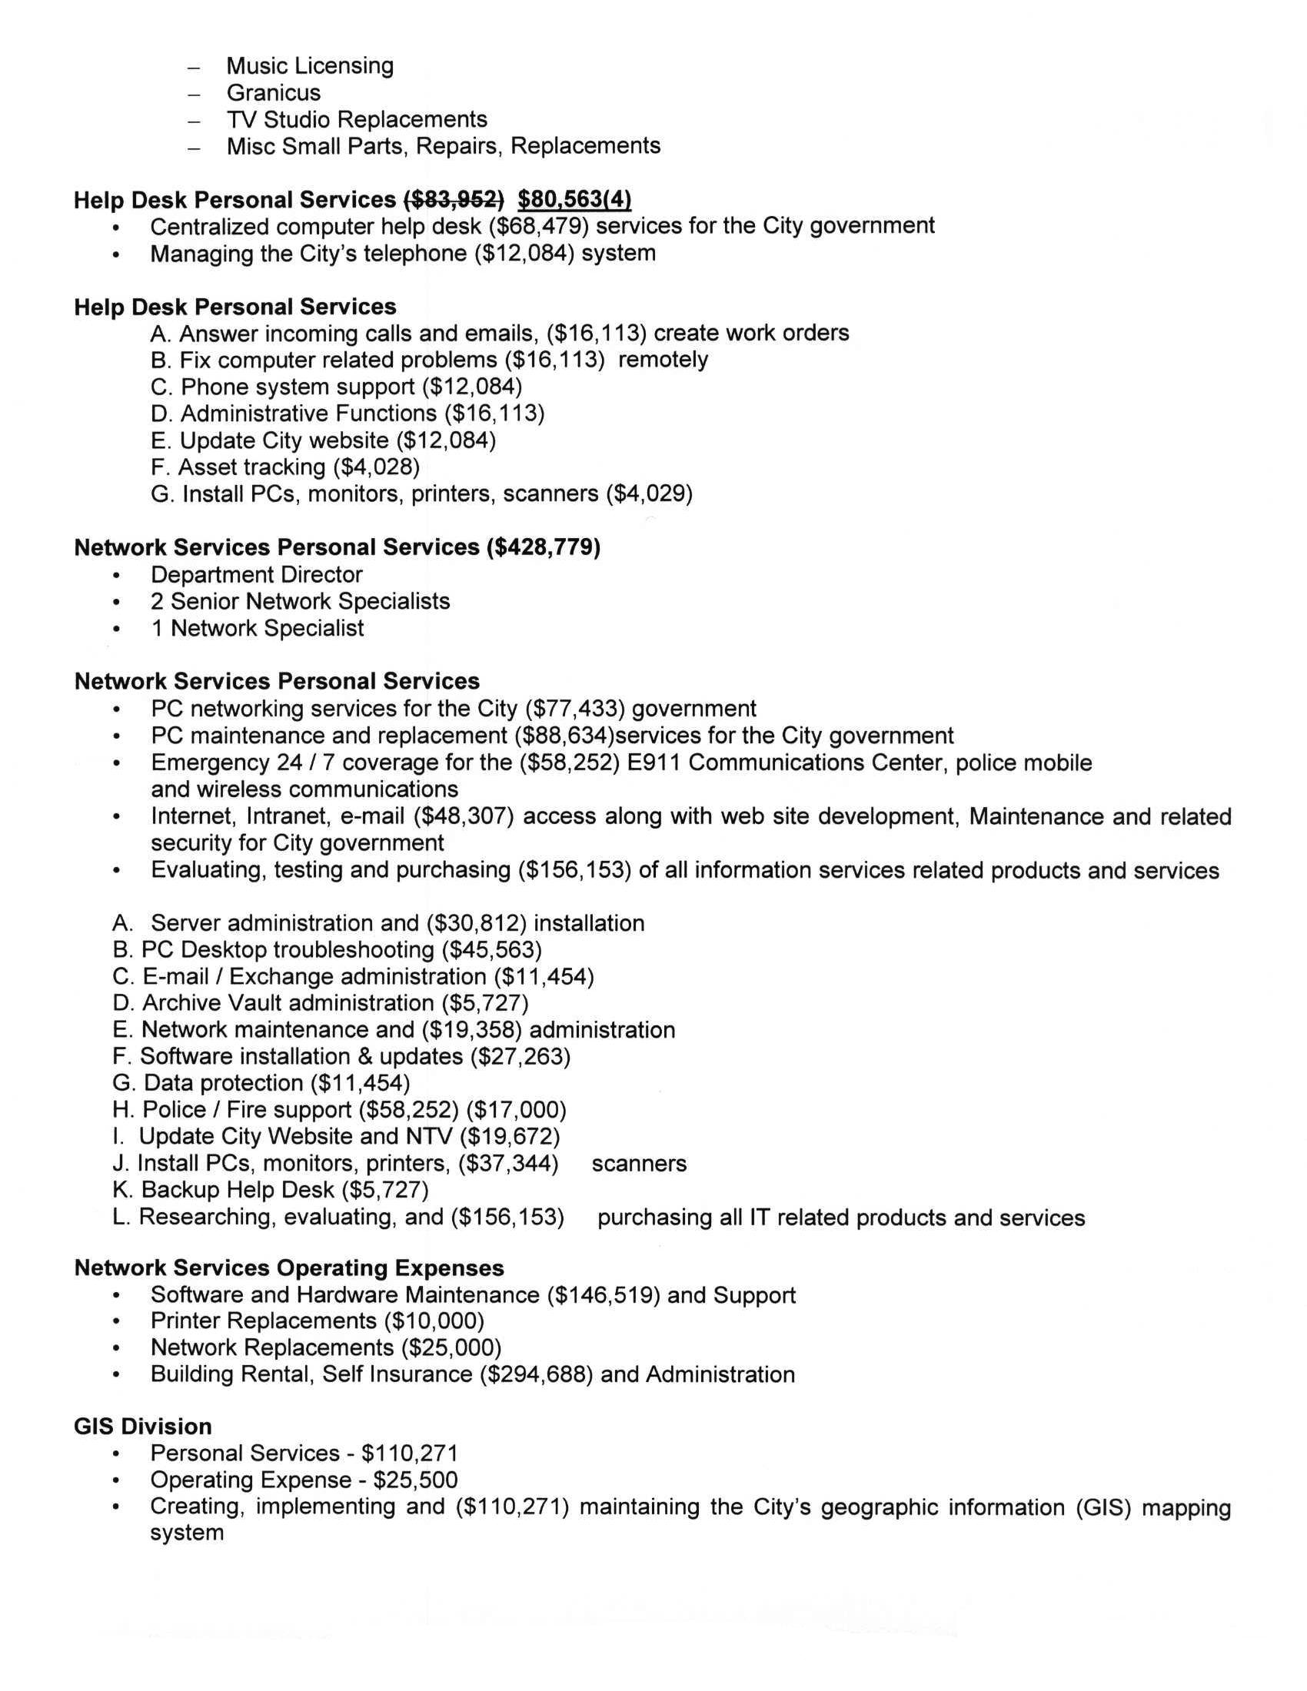
Attachment 12 / Page 4 of 4


